**A Project Report on**

# PLATE TO PALATE: ENHANCING CULINARY EXPERIENCES WITH RECIPE RECOGNITION

**Industrial Internship Project report submitted in partial fulfilment of the**

**Requirements for the award of the degree in**

**BACHELOR OF TECHNOLOGY**

**IN**

## COMPUTER SCIENCE AND ENGINEERING

**BY**

**J. VYSHNAVI 218X1A0529**

**M. RAVALI DEEPTHI 218X1A0542**

**B. KODANDA RAM PRASAD 218X1A0543**

**D. PRABHAS 218X1A0512**

**Under the Esteemed Guidance of**

**Mr. CH. H S CHANDRA MOULI, M.Tech**

**Assistant Professor**



**DEPARTMENT OF COMPUTER SCIENCE AND ENGINEERING**

## KALLAM HARANADHAREDDY INSTITUTE OF TECHNOLOGY

## (AUTONOMOUS)

**ACCREDITED BY NAAC WITH ‘A’ GRADE**

**(APPROVED BY AICTE, AFFLIATED TO JNTUK, KAKINADA)NH-5, CHOWDAVARAM, GUNTUR** – **522019.**

**2021 – 2025**

## KALLAM HARANADHAREDDY INSTITUTE OF TECHNOLOGY

## (AUTONOMOUS)

**ACCREDITED BY NAAC WITH ‘A’ GRADE**

**(APPROVED BY AICTE, AFFLIATED TO JNTUK, KAKINADA)**

**NH-5, CHOWDAVARAM, GUNTUR** - **522019**

**DEPARTMENT OF COMPUTER SCIENCE AND ENGINEERING**



## CERTIFICATE

This is to certify that the Industrial Internship Project work entitled **PLATE TO PALATE:**

**ENHANCING CULINARY EXPERIENCESS WITH RECIPE RECOGNITION** being

submitted by

|  |  |
| --- | --- |
| **J. VYSHNAVI** | **218X1A0529** |
| **M. RAVALI DEEPTHI** | **218X1A0542** |
| **B. KONDA RAM PRASAD** | **218X1A0543** |
| **D. PRABHAS** | **218X1A0512** |
|  |  |

in partial fulfillment for the award of the Degree of Bachelor of Technology in Computer Science and Engineering in the Kallam Haranadhareddy Institute of Technology is a record of bonafide work carried out by them.

|  |  |
| --- | --- |
| **Internal Guide**  **CH. H S CHANDRA MOULI,**M.Tech  Assistant Professor | **Headof the Department**  **Dr. V RAJIV JETSON** ,M.Tech,Ph.D  Professor & HOD |

**External Examiner**

## CERTIFICATE FROM INTERN ORGANIZATION

This is to certify that J. VYSHNAVI, M. RAVALI DEEPTHI, B. KODANDA RAM PRASAD and D. PRABHAS Reg.No. 218X1A0529, 218X1A0542, 218X1A0543 and 218X1A0512 of Kallam

Haranadhareddy Institute of Technology underwent industrial internship in SMART INTERNZ from 15-07-2024 to 02-11-2024. The overall performance of the intern during his/her internship is found to be Satisfactory.

|  |  |
| --- | --- |
| **J. VYSHNAVI** | **218X1A0529** |
| **M. RAVALI DEEPTHI** | **218X1A0542** |
| **B. KODANDA RAM PRASAD** | **218X1A0543** |
| **D. PRABHAS** | **218X1A0512** |
|  |  |

*Authorized Signatory with Date and Seal*

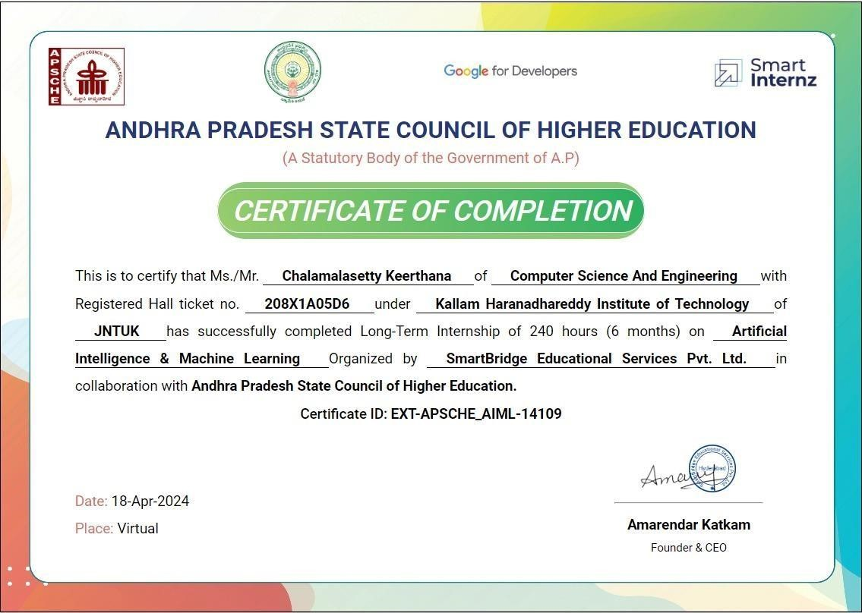

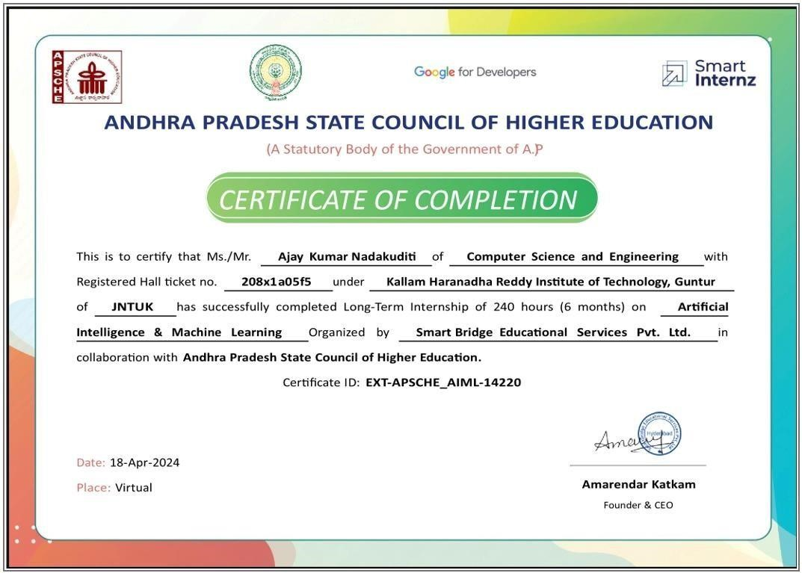

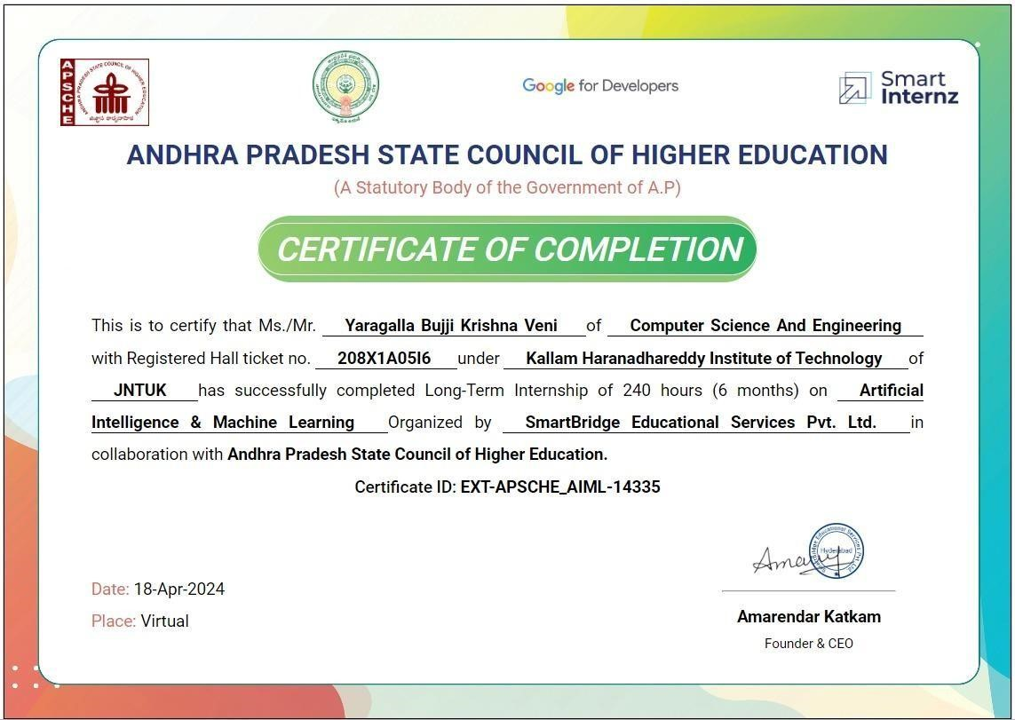

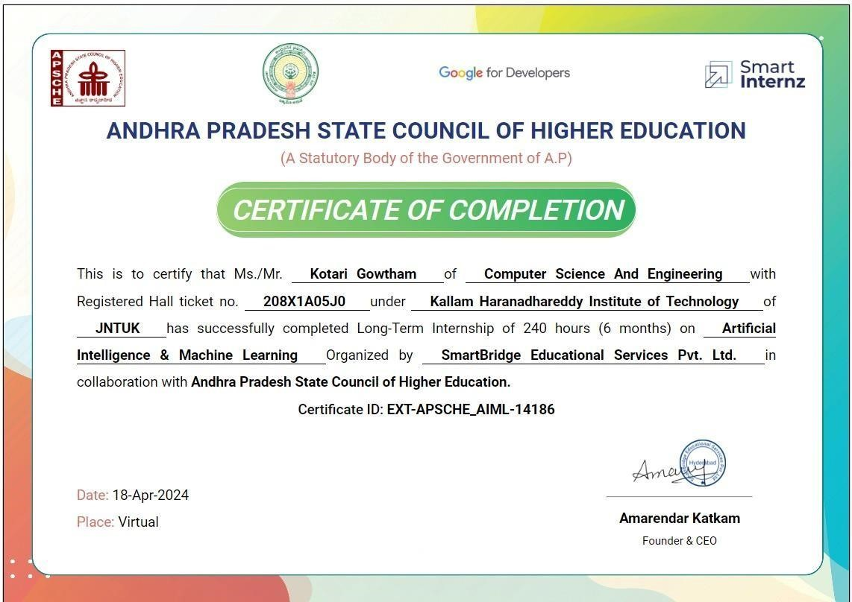

## DECLARATION

We J. VYSHNAVI (218X1A0529), M. RAVALI DEEPTHI (218X1A0542), B.KODANDA RAM PRASAD (218X1A0543), D.PRABHAS (218X1A0512), hereby declare that the project report titled “**PLATE TO PALATE:ENHANCING CULINARY EXPERIENCES WITH**

**RECIPE RECOGNITION**” under the guidance of **CH. H S CHANDRA MOULI,** M.Tech

is submitted in partial fulfilment of the requirements for the degree of Bachelor of Technology in Computer Science and Engineering.

This is a record of bonafide work carried out by us and the results embodied in this project have not been reproduced or copied from any source. The results embodied in this project have not been submitted to any other university for the award of any degree.

|  |  |
| --- | --- |
| **J. VYSHNAVI** | **218X1A0529** |
| **M.RAVALI DEEPTHI** | **218X1A0542** |
| **B. KODANDA RAM PRASAD** | **218X1A0543** |
| **D.PRABHAS** | **218X1A0512** |

## ACKNOWLEDGEMENT

We profoundly grateful to express our deep sense of gratitude and respect towards **Sri. KALLAM MOHAN REDDY**, **Chairman, KHIT**, **Guntur** for his precious support in the college**.**

We are thankful to **Dr. M. UMA SANKAR REDDY**, Director, KHIT, Guntur for his encouragement and support for the completion of the project.

We are much thankful to **Dr. B. SIVA BASIVI REDDY**, Principal, KHIT, Guntur for his support during and until the completion of the project.

We are greatly indebted to **Dr. V RAJIV JETSON, M.Tech, Ph.D** Professor &Head of the department, Computer Science and Engineering, KHIT, Guntur for providing the laboratory facilities fully as and when required and for giving us the opportunity to carry the project work in the college during Industry Internship.

We are also thankful to our Project Coordinator **Mr. G MANTHRU NAIK** who helped us in each step of our Project.

We extend our deep sense of gratitude to our Internal Guide **Mr. CH. CHANDRA MOULI**,M.Tech Assistant Professor and other Faculty Members & Support staff for their valuable suggestions, guidance and constructive ideas in each and every step, which was indeed of great help towards the successful completion of our project.

|  |  |
| --- | --- |
| **J. VYSHNAVI** | **218X1A0529** |
| **M.RAVALI DEEPTHI** | **218X1A0542** |
| **B. KODANDA RAM PRASAD** | **218X1A0543** |
| **D. PRABHAS** | **218X1A0512** |

### ABSTRACT

The "Recipe Recognition System" project aims to revolutionize culinary exploration and recipe discovery by employing Convolutional Neural Networks (CNNs) in tandem with traditional Recognition methodologies. This novel approach offers a more holistic understanding of recipe content, enabling more accurate and personalized Recognitions tailored to individual preferences and dietary requirements. The integration of CNNs enhances the Recognition process in several key ways. Firstly, the image recognition capabilities enable the system to identify visually similar dishes, facilitating Recognitions based on aesthetic appeal and presentation. Users can explore recipes that resonate with their culinary preferences simply by browsing through visually engaging images. Ultimately, the "Recipe Recognition System" aims to empower users to discover and explore a wide variety of culinary delights tailored to their tastes and dietary preferences. Whether seeking quick and easy weeknight meals or gourmet creations for special occasions, our system will serve as a valuable tool for culinary enthusiasts, novices, and seasoned chefs alike, fostering a deeper appreciation for the art and joy of cooking

### TABLE OF CONTENTS

**Contents Page No**

Certificate 4-5

Declaration 6

Acknowledgement 7

Abstract 8

1. **INTRODUCTION 09-03**
   1. Project Idea 01
   2. Motivation of the Project 01-02
   3. Problem Statement 02-03
   4. Statement of scope 03
   5. Goals and objectives 03
2. **LITERATURE SURVEY 04-07**
   1. Literature Survey 04-06
   2. Existing System 07
   3. Disadvantages of the Existing System 07
   4. Feasibility Study 07-08
3. **PROPOSED SYSTEM 09-12**
   1. Proposed System 09
   2. Methodology 09-10
   3. Advantages 10
   4. Approaches 10-12
4. **SYSTEM REQUIREMENTS SPECIFICATION 13**
   1. Software Requirements 13
   2. Technologies used 13
   3. Hardware Requirements 13
5. **SYSTEM DESIGN 14-24**
   1. System Architecture 14-15
   2. Module Description 15-19
   3. UML Diagrams 19-24
      1. Use Case Diagram 21
      2. Sequence Diagram 22
      3. Activity Diagram 22-24
6. **IMPLEMENTATION 25-43**
   1. Algorithms 25-36
      1. What is deep learning 25-26
      2. How deep learning Works 26-28
      3. ResNext CNN 28-33
         1. Introduction 28-29
         2. Architecture 29-33
      4. LSTM 33-35
      5. Algorithm 35-36
      6. Implementation Procedure 36-36
   2. Coding (Source Code) 36-43
   3. Dataset Details 43-43
7. **SYSTEM TESTING 44-51**
   1. Testing Introduction 44-49
      1. Unit testing 45-46
      2. Integration testing 47-48
      3. User interface testing 48-49
   2. Test Cases 50-51
8. **OUTPUT SCREENS 52-54**
9. **TIMELINE OF THE PROJECT 55-56**
10. **CONCLUSION 57-57**
    1. Future Enhancement 57-57

**REFERENCES 58-60**

### LIST OF FIGURES

**Contents Page No**

Figure 1: Architecture 14

Figure 2: Dataset 16

Figure 3: Train test split 17

Figure 4: Use case Diagram 21

Figure 5: Sequence Diagram 22

Figure 6: Activity Diagram 23

Figure 7: Activity Diagram 24

**LIST OF TABLES**

**Contents Page No**

Table 1: Literature Survey Works 6

Table 2: Test Cases 51

Table 3: Timeline of the Project 56

# 1. INTRODUCTION

**1.1 Project idea:**

In the contemporary digital landscape, the abundance of online recipe content presents both opportunities and challenges for culinary enthusiasts. While the internet offers a vast repository of culinary inspiration, navigating through countless recipes to find dishes that align with individual tastes, dietary preferences, and ingredient availability can be daunting.

To address these challenges, we introduce the Recipe Recognition System, a novel platform designed to revolutionize recipe discovery and meal planning. Leveraging state-of-the-art technologies such as Convolutional Neural Networks (CNNs) alongside traditional Recognition methodologies, our system aims to provide users with intuitive, personalized, and visually engaging recipe Recognitions. By analyzing both image and text data associated with recipes, the system extracts meaningful features to enhance Recognition accuracy.

**1.2 Motivation of the project:**

The Recipe Recognition System is driven by the need to simplify recipe discovery and meal planning in today's digital age. With an abundance of online recipe content, users often struggle to find dishes that match their preferences, dietary needs, and ingredient availability. Traditional Recognition systems fall short in capturing the nuanced aspects of recipes, such as visual appeal and ingredient combinations. By integrating Convolutional Neural Networks (CNNs) with conventional techniques, our system aims to address these challenges. CNNs analyze both image and text data, allowing for a comprehensive understanding of recipe content. Ultimately, our goal is to empower users to explore new culinary horizons, discover diverse recipes, and simplify their cooking experience in a digital world.

**1.3 Problem Statement**

Users frequently encounter difficulties in finding recipes that align with their dietary restrictions and ingredient availability. This highlights the need for an innovative solution that combines advanced technologies with traditional Recognition methodologies to provide tailored recipe Recognitions.

The Recipe Recognition System aims to address these challenges by leveraging Convolutional

Neural Networks (CNNs) to analyze both image and text data associated with recipes. Ultimately, the goal is to simplify the recipe discovery process, inspire culinary exploration, and enhance the overall cooking experience for users in an increasingly digitalized world.

**1.4 Statement of Scope:**

The scope of the Recipe Recognition System project encompasses several crucial aspects aimed at developing an efficient and user-centric platform. This includes collecting and preprocessing a diverse dataset of recipe images and text descriptions to ensure data quality. The project involves designing and training Convolutional Neural Network models to extract relevant features from recipe images and text, thereby facilitating accurate Recognitions. Additionally, user interface design is pivotal, ensuring intuitive interaction for inputting preferences. Evaluation using standard metrics such as accuracy and precision, alongside iterative refinement based on user feedback, ensures the system's continual improvement. Deployment options, either standalone or integration into existing platforms, guarantee accessibility to a broad user base. While the project emphasizes system functionality, it does not extend to content creation or implementing advanced features beyond the scope of CNNs for recipe analysis.

**1.4 Goals and objectives:**

The objective of the Recipe Recognition System project is to develop an innovative platform that transforms the way users discover and plan meals. Leveraging Convolutional Neural Networks (CNNs), the system aims to analyze recipe images and text data, extracting meaningful features to enhance Recognition accuracy. Emphasis is placed on recognizing visually appealing dishes, identifying key ingredients, and considering cooking techniques to improve Recognition relevance. Through user-friendly interfaces and iterative refinement based on performance metrics and user feedback, the system aims to empower users to explore diverse culinary options effortlessly. Ultimately, the project seeks to simplify meal planning, inspire culinary creativity, and enrich the overall cooking experience for users.

**2. LITERATURE SURVEY**

* 1. **Literature survey:**

**As per the survey Baki Komsuoglu bulvarı**

While technology facilitates our lives, it also allows us to lead a quality, efficient energy and to do more productive work in less time. One of our basic needs that takes our time is to eat. One of the problems people face is, ‘‘What can I cook today?’’ It is the question. The Smart Recipe Suggestion System (SRSS) is a system that can make food Recognitions to the person with the materials available. This system is designed as a mobile application, including the deep learning method, to answer people’s questions during the day. This paper proposes an approach that recognizes the person’s materials with image processing technology and presents the most suitable meal suggestions to be made with those materials. Recipes are collected from web sites through RabbitMQ. Food items are captured from images by using object detection processes through deep learning. Available food items are modeled as NoSQL and stored to MongoDB document based databases. For the real-world application Firebase mobile cloud platform is used.

**As per the M. Gim, D. Park, M. Spranger, K. Maruyama and J. Kang,**

Countless possibilities of recipe combinations challenge us to determine which additional ingredient goes well with others. In this work, we propose RecipeBowl which is a cooking Recognition system that takes a set of ingredients and cooking tags as input and suggests possible ingredient and recipe choices. We formulate a recipe completion task to train RecipeBowl on our constructed dataset where the model predicts a target ingredient previously eliminated from the original recipe. The RecipeBowl consists of a set encoder and a 2-way decoder for prediction. For the set encoder, we utilize the Set Transformer that builds meaningful set representations. Overall, our model builds a set representation of an leaveoneout recipe and maps it to the ingredient and recipe embedding space. Experimental results demonstrate the effectiveness of our approach. Furthermore, analysis on model predictions and interpretations show interesting insights related to cooking knowledge.

**As per the survey Devis Bianchini, Valeria De Antonellis, Nicola De Franceschi**

In the literature, several researches on food Recognition and automatic menu generation have been proposed, taking into account different aspects, such as personal and cultural preferences, health and religion constraints, menu composition and recipe co-occurrence. However, recommending recipes and menus, which not only meet the user's preferences, but are also compliant with best food habits, is still an open issue. This paper presents the PREFer food recommender system, apt to provide users with personalized and healthy menus, taking into account both user's short/long-term preferences and medical prescriptions.

**As per the survey W. Min, S. Jiang and R. Jain**

A growing proportion of the global population is becoming overweight or obese, leading to various diseases (e.g., diabetes, ischemic heart disease and even cancer) due to unhealthy eating patterns, such as increased intake of food with high energy and high fat. Food Recognition is of paramount importance to alleviate this problem. Unfortunately, modern multimedia research has enhanced the performance and experience of multimedia Recognition in many fields such as movies and POI, yet largely lags in the food domain. This article proposes a unified framework for food Recognition, and identifies main issues affecting food Recognition including incorporating various context and domain knowledge, building the personal model, and analyzing unique food characteristics. We then review existing solutions for these issues, and finally elaborate research challenges and future directions in this field. To our knowledge, this is the first survey that targets the study of food Recognition in the multimedia field and offers a collection of research studies and technologies to benefit researchers in this field.

**As per the survey Mayumi Ueda, Mari Takahata, and Shinsuke Nakajima**

There are many websites and researches that involve cooking recipe Recognition. However, these websites present cooking recipes on the basis of entry date, access frequency, or the recipe’s user ratings. They do not reflect the user’s personal preferences. We have proposed a personalized recipe Recognition method that is based on the user’s food preferences. For extracting the user’s food preferences his/her recipe browsing and cooking history. In this paper, we present a method for extracting the user’s preferences. In the experimental results, extracting the user’s favorite ingredients were detected with a 60 to 83% of precision. And extracting the unfavorite ingredients were detected with 14.7% of precision, and 58% of recall. Furthermore, the F-measure value for extraction of favorite ingredients was 60.8% when we focused on the top 20 ingredients.

**2.2 Existing system:**

The current methods of recipe identification and categorization largely rely on manual input or the use of predefined tags and labels in recipe databases. These systems typically require users to either search for recipes by name or input ingredients to retrieve matching recipes. While these systems are useful, they lack automation in recognizing and classifying recipes directly from visual content, such as images. Furthermore, existing systems do not leverage advanced deep learning techniques to accurately recognize recipes from images, often relying on keyword matching or text-based approaches.

**2.3 Disadvantages of Existing system:**

* + Manual search or text-based input is required to find recipes.
  + Inability to automatically classify recipes directly from images.
  + Inaccurate or slow identification due to the absence of modern deep learning models.
  + Lack of personalization or advanced filtering based on visual content.

**2.4 Feasibility Study:**

The feasibility of the project is analysed in this phase and business proposal is put forth with a very general plan for the project and some cost estimates. During system analysis the feasibility study of the proposed system is to be carried out. This is to ensure that the proposed system is not a burden to the company. For feasibility analysis, some understanding of the major requirements for the system is essential.

Three key considerations involved in the feasibility analysis are

* + Economical feasibility
  + Technical feasibility
  + Social feasibility

**Economical Feasibility**

This study is carried out to check the economic impact that the system will have on the organization. The amount of fund that the company can pour into the research and development of the system is limited. The expenditures must be justified. Thus the developed system as well within the budget and this was achieved because most of the technologies used are freely available. Only the customized products had to be purchased.

**Technical Feasibility**

This study is carried out to check the technical feasibility, that is, the technical requirements of the system. Any system developed must not have a high demand on the available technical resources. This will lead to high demands on the available technical resources. This will lead to high demands being placed on the client. The developed system must have a modest requirement, as only minimal or null changes are required for implementing this system.

**Social Feasibility**

The aspect of study is to check the level of acceptance of the system by the user. This includes the process of training the user to use the system efficiently. The user must not feel threatened by the system, instead must accept it as a necessity. The level of acceptance by the users solely depends on the methods that are employed to educate the user about the system and to make him familiar with it. His level of confidence must be raised so that he is also able to make some constructive criticism, which is welcomed, as he is the final user of the system.

# 3. PROPOSED SYSTEM

**3.1 Proposed system:**

The proposed Recipe Recognition System aims to revolutionize recipe identification by using a Convolutional Neural Network (CNN) to recognize recipes directly from images. The system will be capable of processing and analyzing an image of a dish and classifying it into predefined categories based on learned features.

**3.2. Methodology:**

Convolutional Neural Networks (CNNs) have indeed transformed many areas of computer vision, including the specific domain of food classification. In this context, CNNs are particularly effective because they can directly learn to recognize and differentiate among various types of foods from images, which is crucial for tasks like nutritional analysis, diet tracking, and automated cooking assistance.

In a food classification task, the convolutional layers of a CNN play a critical role. These layers apply numerous filters to the input images to capture and encode different visual features, such as textures of a grilled surface, shapes of different fruits, or colors typical of certain foods. For instance, the early layers might detect edges and colors, while deeper layers could identify more complex patterns like the flakiness of a pastry or the glossiness of fresh vegetables.

Pooling layers further support this process by downsampling the feature maps generated by the convolutional layers, reducing the spatial dimensions of the data. This not only diminishes the computational load and memory usage but also makes the model more robust to variations in the position and size of food items within images. For example, pooling can help the model recognize a pizza whether it's centered in the image or partially cut off at the edge.

Overall, CNNs offer a powerful tool for automated food classification, leveraging their hierarchical learning structure to interpret complex and varied visual data directly from raw pixels, significantly benefiting areas like health monitoring, culinary exploration, and automated food processing.

**3.3 Advantages:**

* **Image-based Recipe Identification:** Users can upload an image, and the system will recognize and classify the recipe.
* **Deep Learning for High Accuracy:** The CNN model will be trained on a large dataset of dish images to improve recognition accuracy.
* **Scalability:** The system can be expanded to recognize a wide variety of recipes from different cuisines.

**Block diagram:**

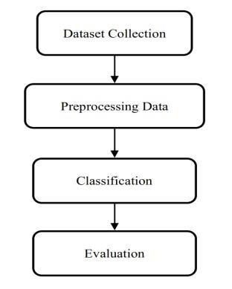

**3.4 Approaches:**

**1. Image Recognition**

* **Convolutional Neural Networks (CNNs)**: Used for image classification to identify

ingredients or finished dishes from photos.

* **Transfer Learning**: Utilizing pre-trained models like ResNet or Inception for better

accuracy with fewer data.

**2. Text Analysis**

* **Natural Language Processing (NLP)**: Parsing ingredient lists and instructions from

recipe texts to extract relevant information.

* **Named Entity Recognition (NER)**: Identifying and categorizing ingredients,

cooking methods, and measurements from textual descriptions.

**3. Multimodal Approaches**

Combining both image and text analysis to create a more robust recognition system.

For example, using images of ingredients along with recipe texts to improve accuracy.

**4. Reinforcement Learning**

Using feedback from user interactions to improve the system's recommendations over

Time, particularly in suggesting recipes based on ingredients users have on hand.

**5. Database and Semantic Matching**

Creating a structured database of recipes and using semantic matching to find similar

recipes based on user input or available ingredients.

**6. Crowdsourcing and User Contributions**

Allowing users to submit and tag recipes, which helps improve the dataset and

recognition accuracy through community input.

**7. Feature Extraction**

Identifying and extracting features from images (like color, texture, and shape) and

text (like ingredient frequency and recipe complexity) to enhance recognition.

**8. Machine Learning Algorithms**

Implementing supervised learning models for classification tasks, using labeled

datasets of images and recipe texts.

**9. Interactive Systems**

Building systems that allow users to engage with the recognition process, such as

confirming ingredient detection or suggesting alternatives based on available items.

**10. Contextual Analysis**

Understanding the context of recipes based on dietary restrictions, cuisines, and

seasonal ingredients to enhance relevance in recognition.

# 4. SYSTEM REQUIREMENT SPECIFICATION

**Software Requirements:**

Operating System : Windows 7/8/10

Server side Script : HTML, CSS, Bootstrap & JS

Programming Language : Python

Libraries : Flask,Pandas, Mysql.connector, Os, Smtplib, Numpy

|  |  |
| --- | --- |
| IDE/Workbench | : PyCharm |
| Technology | : Python 3.6+ |
| Server Deployment | : Xampp Server |
| Database | : MySQL |

**Hardware Requirements:**

Processor - I3/Intel Processor

Hard Disk - 160GB

Key Board - Standard Windows Keyboard

Mouse - Two or Three Button Mouse

Monitor - SVGA

RAM - 8GB

**Technologies used:**

1. Computer Vision

2. Natural Language Processing (NLP)

3. Machine Learning Frameworks

4. Databases and APIs

5. Cloud Computing

6. User Interface Technologies

7. Data Annotation Tools

8. Reinforcement Learning Environments

9. Semantic Search Technologies

10. Multimodal Learning Frameworks

|  |  |  |  |
| --- | --- | --- | --- |
|  |  |  |  |
|  |  |  |  |
|  |  |  |  |
|  |  |  |  |
|  |  |  |  |
|  |  |  |  |
|  |  |  |  |

# 

# 5. SYSTEM DESIGN

**5.1System Architecture:**

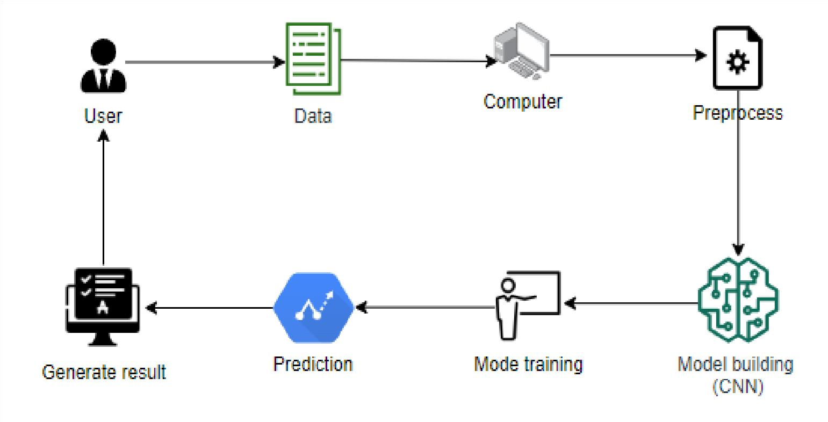

* 1. **Modules Description:**

**1. System:**

**1.1 Create Dataset:**

In this module, the dataset containing images for recipie prediction is divided into two subsets the training dataset and the testing dataset. This split is typically done with a test size of around 20-30%. The training dataset is used to teach the model, while the testing dataset is used to evaluate its performance.

**2. Data Pre-Processing:**

Data preprocessing is a data mining technique which is used to transform the raw data in a useful and efficient format

**2.1. Missing Data**:

This situation arises when some data is missing in the data. It can be handled in

various ways.

**2.2. Noisy Data**:

Noisy data is a meaningless data that can’t be interpreted by machines. It can be

generated due to faulty data collection, data entry errors etc

**3. Admin:**

**3.1 Login**

Admin can login with the default credential.

**3.2** **Add food details:**

* He can add food (name, image, incredents, making procedure, youtube link for making procedure).
* And he can also Edit and ddelete those food details.

**4. User:**

* 1. **Register and Login**

In this application, users are required to register and create their own accounts to

access the system's functionalities. Upon registration, users can log in using their

credentials to avail themselves of the various features and services provided by

the application.

**4.2 prediction:**

* It loads the model that which was created from the training part, choose the images from the system. And then the image is changed into array using img_to_array method.
* For changing binary values we perform matrix division operation. After converting the binary values we load binary converted data to model for prediction.
* After predicting we will get recipe name.

**5.3 UML Diagrams:**

**5.3.1 USE CASE DIAGRAM**

A use case diagram in the Unified Modeling Language (UML) is a type of behavioral diagram defined by and created from a Use-case analysis. Its purpose is to present a graphical overview of the functionality provided by a system in terms of actors, their goals,and any dependencies between those use cases . The main purpose of a use case diagram is to show what system functions are performed for which actor . Roles of the actors in the system can be depicted.

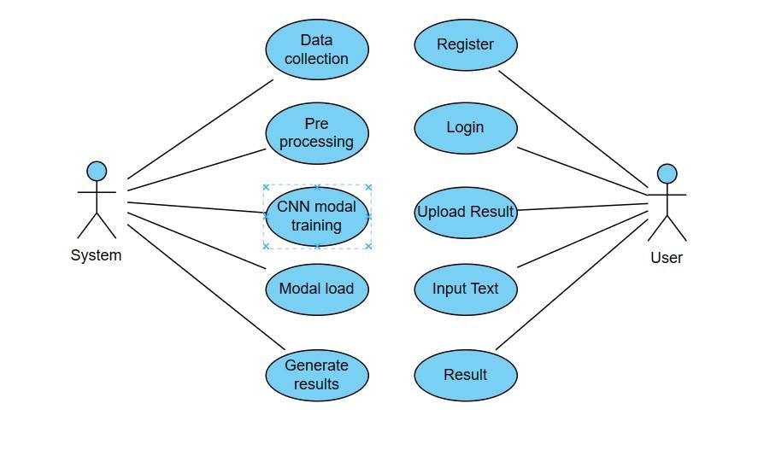

**5.3.2 Sequence Diagram:**

A sequence diagram in Unified Modeling Language (UML) is a kind of interaction diagram that shows how processes operate with one another and in what order. It is a construct of a Message Sequence Chart. Sequence diagrams are sometimes called event diagrams, event scenarios, and timing diagrams.

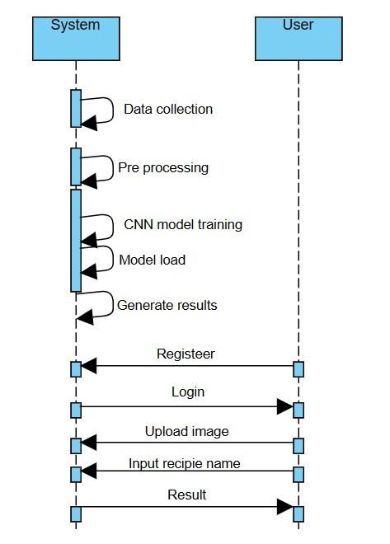

**5.3.3 Activity Diagram:**

Activity diagrams are graphical representations of workflows of stepwise activities and actions with support for choice, iteration and concurrency. In the Unified Modeling Language, activity diagrams can be used to describe the business and operational step-by-step workflows of components in a system. An activity diagram shows the overall flow of control.

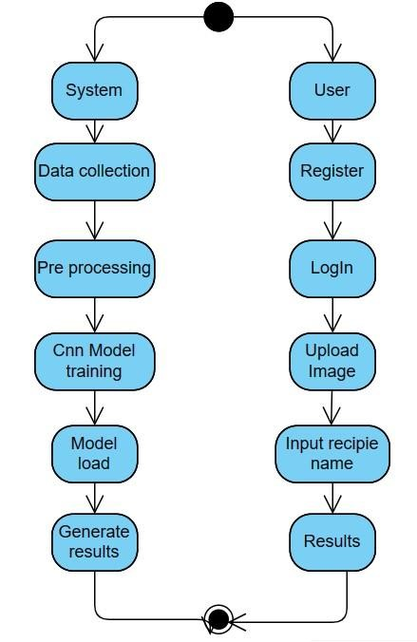

# 6. IMPLEMENTATION

**6.1 Algorithms:**

**6.1.1what is deep learning**

Deep learning is a method in artificial intelligence (AI) that teaches computers to process data in a way that is inspired by the human brain. Deep learning models can recognize complex patterns in pictures, text, sounds, and other data to produce accurate insights and predictions. It focuses on using neural networks with many layers (hence "deep") to model and understand complex patterns in data.

**Types of Deep Learning Models**:

* **Convolutional Neural Networks (CNNs)**: Primarily used for image data, capturing spatial hierarchies and features.
* **Recurrent Neural Networks (RNNs)**: Designed for sequential data, like time series or natural language, capturing temporal dependencies.
* **Generative Adversarial Networks (GANs)**: Comprising two networks (generator and discriminator) that compete against each other to create realistic data.

**6.1.3 How Deep Learning Works:**

Deep learning works through the use of neural networks, which are designed to simulate the way the human brain processes information. Here’s a breakdown of how it functions:

1. Neural Network Architecture
2. Forward Propagation
3. Loss Function
4. Back propagation
5. Training Process
6. Regularization Techniques
7. Testing and Validation
8. Deployment

**6.1.3 ResNext CNN**

**6.1.3.1 Introduction:**

ResNeXt is a convolutional neural network architecture that builds on the concepts introduced by ResNet (Residual Network) while incorporating the idea of "cardinality," which refers to the number of paths or branches in the network. This design allows ResNeXt to achieve better performance and efficiency in image classification tasks

**Key Features of ResNeXt:**

1. Cardinality

2. Residual Learning

3. Modular Design

4. Group Convolutions

5. Performance

**6.1.3.2 Architecture Overview:**

* + **Input Layer**: Accepts the input image.
  + **Stem Block**: The initial layers that process the input image.
  + **Cardinal Blocks**: These blocks consist of multiple paths with different convolution operations, followed by batch normalization and activation functions.
  + **Global Average Pooling**: Reduces the feature map size to a single vector for each class.
  + **Fully Connected Layer:** Produces the final class probabilities.

**6.1.4 Long short term memory:**

Long Short-Term Memory (LSTM) networks are a type of recurrent neural network (RNN) designed to handle sequences of data and are particularly effective for tasks that involve time series or sequential data, such as natural language processing, speech recognition, and more.

**6.1.5 Algorithm:**

**Step 1: Data Collection**

Gather a dataset of food images with corresponding recipe labels.

**Step 2: Data Preprocessing** 1. **Load Images**:

Load images from the dataset.

* 1. **Resize Images**: Resize all images to a uniform size (e.g., 224x224 pixels).
  2. **Normalize Images**: Scale pixel values to the range [0, 1].
  3. **Augment Data**: Apply transformations (rotation, flipping, etc.) to increase dataset diversity.
  4. **Split Data**: Divide the dataset into training, validation, and test sets (e.g., 70% training, 15% validation, 15% test).
  5. **Label Encoding**: Convert categorical labels into one-hot encoded vectors.

**Step 3: Model Development**

* 1. **Initialize Model**: Create a Sequential model.
  2. **Add Layers**:
     + - * Convolutional layers with activation functions (ReLU). o Max pooling layers to reduce dimensionality. o Flatten the output.
         * Dense layers for classification, with a softmax activation for multi-class output.

**Step 4: Compile the Model**

* + Choose an optimizer (e.g., Adam), loss function (e.g., categorical crossentropy), and evaluation metrics (e.g., accuracy).

**Step 5: Train the Model**

* + Fit the model on the training data and validate it using the validation set.
  + Monitor training progress and adjust hyperparameters as necessary.

**Step 6: Evaluate the Model**

* + Assess the model's performance on the test set to ensure it generalizes well.

**Step 7: Make Predictions**

* + Use the trained model to predict classes for new, unseen images.

**Step 8: Post-Processing**

* + Interpret predictions, converting class indices back to recipe names or labels.

**6.2 Source code:**

1. **About page:**

{% extends 'index.html' %}

{% block navbar %}

<nav class="navbar navbar-expand-lg navbar-dark bg-dark px-4 px-lg-5 py-3 py-lg-0">

<a href="" class="navbar-brand p-0">

<h1 class="text-primary m-0"><I class="fa fa-utensils me-3"></i>Recipe Finder</h1>

<! -- <img src="/static/img/logo.png" alt="Logo"> -->

</a>

<buttonclass="navbar-toggler"type="button"data-bs-toggle="collapse"databstarget ="#navbarCollapse">

<span class="fa fa-bars"></span>

</button>

<div class="collapse navbar-collapse" id="navbarCollapse">

<div class="navbar-nav ms-auto py-0 pe-4">

<a href="{{url_for('index')}}" class="nav-item nav-link">Home</a>

<a href="{{url_for('about')}}" class="nav-item nav-link active">About</a>

<a href="{{url_for('register')}}" class="nav-item nav-link">Register</a>

<a href="{{url_for('login')}}" class="nav-item nav-link">LogIn</a>

<! -- <div class="nav-item dropdown">

<a href= "#"class = "nav-link dropdown-toggle"data-bstoggle="dropdown">

Pages</a>

<div class="dropdown-menu m-0">

<a href="booking.html" class="dropdown-item">Booking</a>

<a href="team.html" class="dropdown-item">Our Team</a>

<a href="testimonial.html" class="dropdown-item">Testimonial</a>

</div>

</div> -->

</div>

<! -- <a href ="" class = "btn btn-primary py-2 px-4">Book A Table</a> -->

</div>

</nav>

<div class="container-xxl py-5 bg-dark hero-header mb-5">

<div class="container text-center my-5 pt-5 pb-4">

<h1 class="display-3 text-white mb-3 animated slideInDown">About Us</h1>

</div>

</div>

</div>

{% endblock %}

{% block content %}

<! -- About Start -->

<div class="container-xxl py-5">

<div class="container">

<div class="row g-5 align-items-center">

<div class="col-lg-6">

<div class="row g-3">

<div class="col-6 text-start">

<img class="img- fluid round w-100 wow zoomIn" data-wowdelay ="0.1s" src=”/static/img/

about-1.jpg">

</div>

<div class="col-6 text-start">

<img class="img-fluid rounded w-75 wow zoomIn" data-wow-delay="0.3s" src="/static/img

/about-2.jpg" style="margin-top: 25% ;">

</div>

<div class="col-6 text-end">

<img class="img-fluid rounded w-75 wow zoomIn" data-wow-delay="0.5s" src="/static/img

/about-3.jpg">

</div>

<div class="col-6 text-end">

<img class="img-fluid rounde d w-100 wow zoomIn" data-wowdelay="0.7s"src="/static/img

/about-4.jpg">

</div>

</div>

</div>

<div class="col-lg-6">

<h5 class="section-title ff-secondary text-start text-primary fw-normal">About Us</h5>

<h1 class="mb-4">Welcome to <i class="fa fa-utensils text-primary me-2"></i> Recipe Finder

</h1>

<p class="mb-4"> In the domain of culinary arts and kitchen management, the

ability to swiftly discover recipes based on a set of available ingredients, dietary preferences, and other constraints is invaluable. The "Recipe Finder Using Deep Learning" project aims to harness the power of artificial intelligence to address this need, presenting an innovative solution to recipe discovery and management. Utilizing advanced deep learning techniques, this system is designed to interpret user inputs, which can range from text-based lists of ingredients to images of food items, and generate appropriate recipe recommendations.</p>

<p> class="mb-4"><b>"Discover, Cook, Delight: Transforming Ingredients into Experiences

with AI"</b></p>

</div>

</div>

</div>

</div>

{% endblock %}

**2.Add recipe page:**

% extends 'index.html' %}

{% block navbar %}

<nav class="navbar navbar-expand-lg navbar-dark bg-dark px-4 px-lg-5 py-3 py-lg-0">

<a href="" class="navbar-brand p-0">

<h1 class="text-primary m-0"><I class="fa fa-utensils me-3"></i>Recipe Finder</h1>

<! -- <img src="/static/img/logo.png" alt="Logo"> -->

</a>

<button class="navbar-toggler" type="button"data-bs-toggle="collapse" databstarget t="#navbarCollapse">

<span class="fa fa-bars"></span>

</button>

<div class="collapse navbar-collapse" id="navbarCollapse">

<div class="navbar-nav ms-auto py-0 pe-4">

<a href="{{url_for('admin_home')}}" class="nav-item nav-link">Home</a>

<a href="{{url_for('add_recipie')}}" class="nav-item nav-link active">Add</a>

<a href="{{url_for('view_recipie')}}" class="nav-item nav-link">View</a>

</div>

<a href="{{url_for('index')}}" class="btn btn-primary py-2 px-4">LogOut</a>

</div>

</nav>

<div class="container-xxl py-5 bg-dark hero-header mb-5">

<div class="container text-center my-5 pt-5 pb-4">

<h1 class="display-3 text-white mb-3 animated slideInDown">Add Recipie</h1> </div>

</div>

</div>

{% endblock %}

{% block content %}

<div class="container-xxl py-5">

<div class="container">

<div class="row g-4">

<div class="col-md-12">

<div class="wow fadeInUp" data-wow-delay="0.2s">

<form action="{{url_for('add_recipie')}}"method="postenctype

="multipart/form-data">

<div class="row g-3">

<div class="col-12">

<div class="form-floating">

<inputtype="text"class="form-control" id="name" name="r_name" placeholder="Your

Name" required>

<label for="name">Recipie Name</label>

</div>

</div><br>

<div class="col-12">

<div class="form-floating">

<input type="file" class="form-control" id="image" name="image" accept="image

/*" required>

<label for="image">Image</label>

</div>

</div><br>

<div class="col-12">

<div class="form-floating">

</div>

button class="btn btn-primary w-100 py-3"type=="submit">Submit</button>

</div>

</div>

</form>

</div>

</div>

</div>

</div>

</div>

{% endblock %}

**3. Admin Home Page:**

{% extends 'index.html' %}

{% block navbar %}

<nav class="navbar navbar-expand-lg navbar-dark bg-dark px-4 px-lg-5 py-3 py-lg-0">

<a href="" class="navbar-brand p-0">

<h1 class="text-primary m-0"><i class="fa fa-utensils me-3"></i>Recipe Finder</h1>

</div>

<! -- <img src="/static/img/logo.png" alt="Logo"> -->

</a>

<button class="navbartoggler"type="button"databs="collapse"toggle="collapse"

databstarget="#navbarCollapse">

<span class="fa fa-bars"></span>

</button>

<div class="collapse navbar-collapse" id="navbarCollapse">

<div class="navbar-nav ms-auto py-0 pe-4">

<a href="{{url_for('admin_home')}}" class="nav-item nav-link active">Home</a>

<a href="{{url_for('add_recipie')}}" class="nav-item nav-link">Add</a>

<a href="{{url_for('view_recipie')}}" class="nav-item nav-link">View</a>

</div>

<a href="{{url_for('index')}}" class="btn btn-primary py-2 px-4">LogOut</a>

</div>

</nav>

{% endblock %}

{% block content %}

<div class="container-xxl py-5 bg-dark hero-header mb-5">

<div class="container my-5 py-5">

<div class="row align-items-center g-5">

<div class="col-lg-6 text-center text-lg-start">

<h1 class="display-3 text-white animated slideInLeft">Welcome<br> Admin!</h1>

<p class="text-white animated slideInLeft mb-4 pb-2">"From Pantry to

Plate: Unleashing Culinary Creativity with the Power of AI"</p>

<! -- <a href="" class="btn btn- primary py-sm-3 px-sm-5 me-3 animated

slideInLeft">Book A Table</a> -->

</div>

<div class="col-lg-6 text-center text-lg-end overflow-hidden">

<img class="img-fluid" src="/static/img/hero.png" alt="">

</div>

</div>

</div>

</div>

{% endblock %}

**4. Home Page:**

{% extends 'index.html' %}

{% block navbar %}

<nav class="navbar navbar-expand-lg navbar-dark bg-dark px-4 px-lg-5 py-3 py-lg-0">

<a href="" class="navbar-brand p-0">

<h1 class="text-primary m-0"><i class="fa fa-utensils me-3"></i>Recipe Finder</h1>

<! -- <img src="/static/img/logo.png" alt="Logo"> -->

</a>

<buttonclass="navbar-toggler"type="button"data-bs- toggle="collapse"

data-bs-target="#navbarCollapse">

<span class="fa fa-bars"></span>

</button>

<div class="collapse navbar-collapse" id="navbarCollapse">

<div class="navbar-nav ms-auto py-0 pe-4">

<a href="{{url_for('home')}}" class="nav-item nav-link active">Home</a>

<a href="{{url_for('upload')}}" class="nav-item nav-link">Upload</a>

<a href="{{url_for('search')}}" class="nav-item nav-link">Search</a>

<!-- <div class="nav-item dropdown">

<a href="#" class="nav-link dropdown-toggle" data-bs- toggle

="dropdown">Pages</a>

<div class="dropdown-menu m-0">

<a href="booking.html" class="dropdown-item">Booking</a>

<a href="team.html" class="dropdown-item">Our Team</a>

<a href="testimonial.html" class="dropdown-item">Testimonial</a>

</div>

</div> -->

</div>

<a href="{{url_for('index')}}" class="btn btn-primary py-2 px-4">LogOut</a>

</div>

</nav>

{% endblock %}

{% block content %}

<div class="container-xxl py-5 bg-dark hero-header mb-5">

<div class="container my-5 py-5">

<div class="row align-items-center g-5">

<div class="col-lg-6 text-center text-lg-start">

<h1 class="display-3 text-white animated slideInLeft">Taste Inspired <br> by Technology</h1>

<p class="text-white animated slideInLeft mb-4 pb-2">"From Pantry to Plate: Unleashing Culinary Creativity with the Power of AI"</p>

<! -- <a href="" class="btn btn-primary py-sm-3 px-sm-5 me-3 animated

slideInLeft">Book A Table</a> -->

</div>

<div class="col-lg-6 text-center text-lg-end overflow-hidden">

<img class="img-fluid" src="/static/img/hero.png" alt="">

</div>

</div>

</div>

</div>

{% endblock %}

**5. Index Page:**

!DOCTYPE html>

<html lang="en">

<head>

<meta charset="utf-8">

<title>Recipe Finder</title>

<meta content="width=device-width, initial-scale=1.0" name="viewport">

<meta content="" name="keywords">

<meta content="" name="description">

<!-- Favicon -->

<link href="/static/img/favicon.ico" rel="icon">

<!-- Google Web Fonts -->

<link rel="preconnect" href="https://fonts.googleapis.com">

<link rel="preconnect" href="https://fonts.gstatic.com" crossorigin>

<link href="https://fonts.googleapis.com/css2?family=Heebo:wght@400;500;600&family=Nunito: wght@600;700;800&family=Pacifico&display=swap" rel="stylesheet">

<! -- Icon Font Stylesheet -->

<link href="https://cdnjs.cloudflare.com/ajax/libs/ font-awesome/5.10.0/css/all.min.css" rel="stylesheet">

<link href="https://cdn.jsdelivr.net/npm/bootstrap-icons@1.4.1/font/bootstrap-icons.css" rel="stylesheet">

<! -- Libraries Stylesheet -->

<link href="/static/lib/animate/animate.min.css" rel="stylesheet">

<linkhref="/static/lib/owlcarousel/assets/owl.carousel.min.css" rel="stylesheet">

<linkhref="/static/lib/tempusdominus/css/tempusdominus-bootstrap-4.min.css" rel="stylesheet" />

<! -- Customized Bootstrap Stylesheet -->

<link href="/static/css/bootstrap.min.css" rel="stylesheet">

<! -- Template Stylesheet -->

<link href="/static/css/style.css" rel="stylesheet">

</head>

<body>

<div class="container-xxl bg-white p-0">

<! -- Spinner Start -->

<! -- <div id="spinner" class="show bg-white position-fixed translate-middle w-100 vh-

100 top-50 start-50 d-flex align-items-center justify-content-center">

<div class="spinner-border text-primary"style="width: 3rem; height: 3rem;" role="status">

<span class="sr-only">Loading...</span>

</div>

</div> -->

<! -- Spinner End -->

<! -- Navbar & Hero Start -->

<div class="container-xxl position-relative p-0">

{% block navbar %}

<nav class="navbar navbar-expand-lg navbar-dark bg-dark px-4px-lg-5 py-3 pylg0">

<a href="" class="navbar-brand p-0">

<h1 class="text-primary m-0"><i class="fa fa-utensils me-3"></i>Recipe Finder</h1>

<! -- <img src="/static/img/logo.png" alt="Logo"> -->

</a>

<button class="navbar-toggler" type="button" data-bs-toggle="collapse" data-

bstarget="#navbarCollapse">

<span class="fa fa-bars"></span>

</button>

<div class="collapse navbar-collapse" id="navbarCollapse">

<div class="navbar-nav ms-auto py-0 pe-4">

<a href="{{url_for('index')}}" class="nav-item nav-link active">Home</a>

<a href="{{url_for('about')}}" class="nav-item nav-link">About</a>

<a href="{{url_for('register')}}" class="nav-item nav-link">Register</a>

<a href="{{url_for('login')}}" class="nav-item nav-link">LogIn</a>

<! -- <div class="nav-item dropdown">

<a href="#" class="nav-link dropdown-toggle" data- bstoggle

="dropdown">Pages</a>

<div class="dropdown-menu m-0">

<a href="booking.html" class="dropdown-item">Booking</a>

<a href="team.html" class="dropdown-item">Our Team</a>

<a href="testimonial.html" class="dropdown-item">Testimonial</a>

</div>

</div> -->

</div>

<! -- <a href="" class="btn btn-primary py-2 px-4">Book A Table</a> -->

</div>

</nav>

{% endblock %}

{% block content %}

<div class="container-xxl py-5 bg-dark hero-header mb-5">

<div class="container my-5 py-5">

<div class="row align-items-center g-5">

<div class="col-lg-6 text-center text-lg-start">

<h1 class="display-3 text-white animated slideInLeft">WELCOME! </h1>

<p class="text-white animated slideInLeft mb-4 pb-2">"Unlock a world

of flavor with every recommendation"</p>

<a href="{{url_for ('register')}}" class="btn btn-primary py-sm-3 px-sm-5

me-3 animated slideInLeft">Visit Website</a>

</div>

<div class="col-lg-6 text-center text-lg-end overflow-hidden">

<img class="img-fluid" src="/static/img/hero.png" alt="">

</div>

</div>

</div>

</div>

{% endblock %}

</div>

</div>

{% if message %}

<script> alert("{{ message }}")

</script>

{% endif %}

<! -- JavaScript Libraries -->

<script src="https://code.jquery.com/jquery-3.4.1.min.js"></script>

<script src="https://cdn.jsdelivr.net/npm/bootstrap@5.0.0/dist/js/bootstrap.bundle.min.js">

</script>

<script src="/static/lib/wow/wow.min.js"></script>

<script src="/static/lib/easing/easing.min.js"></script>

<script src="/static/lib/waypoints/waypoints.min.js"></script>

<script src="/static/lib/counterup/counterup.min.js"></script>

<script src="/static/lib/owlcarousel/owl.carousel.min.js"></script>

<script src="/static/lib/tempusdominus/js/moment.min.js"></script>

<script src="/static/lib/tempusdominus/js/moment-timezone.min.js"></script>

<script src="/static/lib/tempusdominus/js/tempusdominus-bootstrap-4.min.js"></script>

<! -- Template Javascript -->

<script src="/static/js/main.js"></script>

</body>

</html>

**6. Login Page:**

{% extends 'index.html' %}

{% block navbar %}

<nav class="navbar navbar-expand-lg navbar-dark bg-dark px-4 px-lg-5 py-3 py-lg-0">

<a href="" class="navbar-brand p-0">

<h1 class="text-primary m-0"><i class="fa fa-utensils me

-3"></i>Recipe Finder</h1>

<! -- <img src="/static/img/logo.png" alt="Logo"> -->

</a>

<button class="navbar-toggler "type="button" data-bs-toggle ="collapse" data-

bs-target ="#navbarCollapse">

<span class="fa fa-bars"></span>

</button>

<div class="collapse navbar-collapse" id="navbarCollapse">

<div class="navbar-nav ms-auto py-0 pe-4">

<a href="{{url_for('index')}}" class="nav-item nav

-link">Home</a>

<a href="{{url_for('about')}}" class="nav-item nav-link"> About</a>

<a href="{{url_for('register')}}" class="nav-item nav-link">Register</a>

<a href="{{url_for('login')}}" class="nav-item nav- link active">Login</a>

<! -- <div class="nav-item dropdown">

<a href="#" class="nav-link dropdown-toggle" data-bs- toggle="dropdown">Pages</a>

<div class="dropdown-menu m-0">

<a href="booking.html" class="drop

down-item">Booking</a>

<a href="team.html" class="dropdown-item">

Our Team</a>

<a href="testimonial.html" class="drop

down-item">Testimonial</a>

</div>

</div> -->

</div>

<! -- <a href="" class="btn btn-primary py-2 px-4">Book A Table</a> -->

</div>

</nav>

<div class="container-xxl py-5 bg-dark hero-header mb-5">

<div class="container text-center my-5 pt-5 pb-4">

<h1class="display-3text-white mb-3text animated slide InDown">LogIn</h1>

</div>

</div>

</div>

{% endblock %}

{% block content %}

<div class="container-xxl py-5">

<div class="container">

<div class="row g-4">

<div class="col-md-12">

<div class="wow fadeInUp" data-wow-delay="0.2s">

<form action="{{url_for('login')}}" method="post">

<div class="row g-3">

<div class="col-md-12">

<div class="form-floating">

<input type="email" class="form-control" id="email" name="email"

placeholder ="Your Email" required>

<label for="email">Your Email</label>

</div>

</div><br>

<div class="col-12">

<div class="form-floating">

<input type="password" class="form-control" id="password" name="password"

Placeholder ="password" required>

<label for="password">Password</label>

</div>

</div><br>

<div class="col-12">

<button class="btn btn-primary w-100 py-3" type="submit"> Login</button>

</div>

</div>

</form>

</div>

</div>

</div>

</div>

</div>

{% endblock %}

**7. Register Page:**

{% extends 'index.html' %}

{% block navbar %}

<nav class="navbar navbar-expand-lg navbar-dark bg-dark px-4 px-lg-5 py-3 py-lg-0">

<a href="" class="navbar-brand p-0">

<h1 class="text-primarym-0"><iclass="fa fa-utensils me-3"></i>Recipe Finder</h1>

<! -- <img src="/static/img/logo.png" alt="Logo"> -->

</a>

<buttonclass="navbar-toggler"type="button" data-bs-toggle="collapse" databstarget ="#navbarCollapse">

<span class="fa fa-bars"></span>

</button>

<div class="collapse navbar-collapse" id="navbarCollapse">

<div class="navbar-nav ms-auto py-0 pe-4">

<a href="{{url_for('index')}}" class="nav-item nav-link">Home</a>

<a href="{{url_for('about')}}" class="nav-item nav-link">About</a>

<a href="{{url_for('register')}}" class="nav-item nav-link active">Register</a>

<a href="{{url_for('login')}}" class="nav-item nav-link">LogIn</a>

<! -- <div class="nav-item dropdown">

<a href="#" class="nav-link dropdown-toggle" data- bstoggle="dropdown">Pages</a>

<div class="dropdown-menu m-0">

<a href="booking.html" class="dropdown-item">Booking</a>

<a href="team.html" class="dropdown-item">Our Team</a>

<a href="testimonial.html" class="dropdown-item">Testimonial</a>

</div>

</div> -->

</div>

<! -- <a href="" class="btn btn-primary py-2 px-4">Book A Table</a> --> </div>

</nav>

<div class="container-xxl py-5 bg-dark hero-header mb-5">

<div class="container text-center my-5 pt-5 pb-4">

<h1 class="display-3 text-white mb-3 animated slideInDown">Registration</h1>

</div>

</div>

</div>

{% endblock %}

{% block content %}

<div class="container-xxl py-5">

<div class="container">

<div class="row g-4”>

<div class="col-md-12">

<div class="wow fadeInUp" data-wow-delay="0.2s">

<form action="{{url_for('register')}}" method="post">

<div class="row g-3">

<div class="col-md-12">

<div class="form-floating">

<input type="text" class="form-control" id="name" name="name"

Placeholder ="Your Name" required>

<label for="name">Your Name</label>

</div>

</div><br>

<div class="col-md-12">

<div class="form-floating">

<input type="email" class="form-control" id="email" name="email" placeholder

="Your Email" required>

<label for="email">Your Email</label>

</div>

</div><br>

<div class="col-12">

<div class="form-floating">

<input type="password" class="form-control" id="password" name="password"

placeholder="password" required>

<label for="password">Password</label>

</div>

</div><br>

<div class="col-12">

<div class="form-floating">

<input type="password" class="form-control" id="c_password" name ="c_password"

placeholder="c_password" required>

<label for="c_password">Conform Password</label>

</div>

</div><br>

<div class="col-12">

<buttonclass="btn btn primary w100 py 3"type="submit">

Register</button>

</div>

</div>

</form>

</div>

</div>

</div>

</div>

</div>

{% endblock %}

**8. Search Page:**

% extends 'index.html' %}

{% block navbar %}

<nav class="navbar navbar-expand-lg navbar-dark bg-dark px-4 px-lg-5 py-3 py-lg-0">

<a href="" class="navbar-brand p-0">

<h1 class="text-primary m-0"><i class="fa fa-utensils me-3"></i>Recipe Finder

</h1>

<! -- <img src="/static/img/logo.png" alt="Logo"> -->

</a>

<button class="navbar-toggler"type="button" data-bs-toggle="collapse" databstarget = "#navbarCollapse">

<span class="fa fa-bars"></span>

</button>

<div class="collapse navbar-collapse" id="navbarCollapse">

<div class="navbar-nav ms-auto py-0 pe-4">

<a href="{{url_for('home')}}" class="nav-item nav-link">Home</a>

<a href="{{url_for('upload')}}" class="nav-item nav-link">Upload</a>

<a href="{{url_for('search')}}" class="nav-item nav-link active">Search</a>

</div>

<a href="{{url_for('index')}}" class="btn btn-primary py-2 px-4">LogOut</a>

</div>

</nav>

<div class="container-xxl py-5 bg-dark hero-header mb-5">

<div class="container text-center my-5 pt-5 pb-4">

<h1 class="display-3 text-white mb-3 animated slideInDown">Search</h1>

</div>

</div>

</div>

{% endblock %}

{% block content %} <center>

{% if prediction %}

{% if prediction == "Unknown" %}

<h2>Prediction:Unknown</h2>

{% else %}

<h2>Predictions</h2>

<h4>Name: {{prediction [0][1]}}</h4>

<h4>Ingredients: {{prediction[0][3]}}</h4>

<h4>Making Procedure: {{prediction[0][4]}}</h4>

<h4>Video Link : <a href="{{prediction[0][5]}}"target="_blank">Clickhere</a></h4>

<img style="width: 300px; height: 200px;" src="/{{prediction[0][2]}}" alt="This image is not supported by your browser!">

{% endif %}

{% endif %}

<div class="container-xxl py-5">

<div class="container">

<div class="row g-4">

<div class="col-md-12">

<div class="wow fadeInUp" data-wow-delay="0.2s">

<form action="{{url_for('search')}}" method="post" enctype="multipart/form-data">

<div class="row g-3">

<div class="col-12">

<div class="form-floating">

<input type="text" class="form-control" id="text" name="text"

placeholder="Search with Recipie name!" required>

<label for="text">Name</label>

</div>

</div><br>

<div class="col-12">

<button class="btnbtn-primary w-100 py3

"type ="submit">Submit</button>

</div>

</div>

</form>

</div>

</div>

</div>

</div>

</div>

</center>

{% endblock %}

**9.Upload Page:**

{% extends 'index.html' %}

{% block navbar %}

<nav class="navbar navbar-expand-lg navbar-dark bg-dark px-4 px-lg-5 py-3 py-lg-0">

<a href="" class="navbar-brand p-0">

<h1 class="text-primary m-0"><i class="fa fa-utensils me-3"></i>RecipeFinder</h1>

<! -- <img src="/static/img/logo.png" alt="Logo"> -->

</a>

<button class="navbar-toggler" type="button" data-bs-toggle="collapse"databs

target="#navbarCollapse">

<span class="fa fa-bars"></span>

</button>

<div class="collapse navbar-collapse" id="navbarCollapse">

<div class="navbar-nav ms-auto py-0 pe-4">

<a href="{{url_for('home')}}" class="nav-item nav-link">Home</a>

<a href="{{url_for('upload')}}" class="nav-item nav-link active">Upload</a>

<a href="{{url_for('search')}}" class="nav-item nav-link">Search</a>

</div>

<a href="{{url_for('index')}}" class="btn btn-primary py-2 px-4">LogOut</a>

</div>

</nav>

<div class="container-xxl py-5 bg-dark hero-header mb-5">

<div class="container text-center my-5 pt-5 pb-4">

<h1 class="display-3 text-white mb-3 animated slideInDown">Upload</h1>

</div>

</div>

</div>

{% endblock %}

{%block content %}

<center>

{% if path %}

{% if path == "Unknown" %}

<h2>Prediction: Unknown</h2> {% else %}

<h2>Predictions</h2>

<h4>Name: {{prediction[0][1]}}</h4>

<h4>Ingredients: {{prediction[0][3]}}</h4>

<h4>Making Procedure: {{prediction[0][4]}}</h4>

<h4>Video Link: <a href="{{prediction[0][5]}}" target="_blank">

Click here</a></h4>

<img style="width: 300px; height: 200px;" src="/{{prediction[0][2]}}" alt="This image is not supported by your browser!">

{% endif %}

{% endif %}

<div class="container-xxl py-5">

<div class="container">

<div class="row g-4">

<div class="col-md-12">

<div class="wow fadeInUp" data-wow-delay="0.2s">

<form action="{{url_for('upload')}}" method="post

" enctype="multipart/form-data">

<div class="row g-3">

<div class="col-12">

<div class="form-floating">

<input type="file"class="form-control"id ="image"name="image" accept="image

/*" required>

<label for="image">Image</label>

</div>

</div><br>

<div class="col-12">

<button class="btn btn-primary w-100 py-3

" type="submit">Submit</button>

</div>

</div>

</form>

</div>

</div>

</div>

</div>

</div>

</center>

{% endblock %}

**10. View Recipe Page:**

{% extends 'index.html' %}

{% block navbar %}

<nav class="navbar navbar-expand-lg navbar-dark bg-dark px-4 px-lg-5 py-3 py-lg-0">

<a href="" class="navbar-brand p-0">

<h1 class="text-primary m-0"><i class="fa fa-utensils me-3"></i>Recipe Finder</h1>

<! -- <img src="/static//static/img/logo.png" alt="Logo"> -->

</a>

<button class="navbar-toggler" type="button" data-bs-toggle="collapse"databstarget ="#navbarCollapse">

<span class="fa fa-bars"></span>

</button>

<div class="collapse navbar-collapse" id="navbarCollapse">

<div class="navbar-nav ms-auto py-0 pe-4">

<a href="{{url_for('admin_home')}}" class="nav-item nav-link">Home</a>

<a href="{{url_for('add_recipie')}}" class="nav-item nav-link">Add</a>

<a href="{{url_for('view_recipie')}}" class="nav-item nav-link active">View</a>

</div>

<a href="{{url_for('index')}}" class="btn btn-primary py-2 px-4">LogOut</a>

</div>

</nav>

<div class="container-xxl py-5 bg-dark hero-header mb-5">

<div class="container text-center my-5 pt-5 pb-4">

<h1 class="display-3 text-white mb-3 animated slideInDown">Recipies</h1>

</div>

</div>

</div>

{% endblock %}

{% block content %}

<div class="container-xxl pt-5 pb-3"> <div class="container">

<div class="row g-4">

{% if datas %}

{% for data in datas %}

<div class="col-lg-3 col-md-6 wow fadeInUp" data-wow-delay="0.1s">

<div class="team-item text-center rounded overflow-hidden">

<div class="rounded-circle overflow-hidden m-4">

<img style="height: 200px; width: 200px;" class="img-fluid"

src="/{{ data[2] }}" alt="Recipe Image">

</div>

<h5 class="mb-0">{{ data[1] }}</h5>

<div class="d-flex justify-content-center mt-3">

<form action="{{ url_for('view_recipie') }}" method="post"

enctype="multipart/form-data">

<input type="hidden" name="id" value="{{ data[0] }}">

<button type="submit" class="btn btn-primary mx-1">View</button>

</form>

</div>

</div>

</div>

{% if loop.index % 4 == 0 %}

</div><div class="row g-4">

{% endif %}

{% endfor %}

{% elif data %}

<center>

<div class="wow fadeInUp" data-wow-delay="0.2s">

<form action="{{url_for('update_recipie')}}"method="post" enctype="multipart/form-data">

<div class="row g-3">

<div class="col-12">

<label style="color: green; margin-top:30px;" for="name">Name</label><br>

<div class="form-floating">

<input style="width: 600px;"type="text" class="form-control"

id="name" name="r_name" value="{{data[0][1]}}" placeholder="Your Name">

</div>

</div><br>

<div class="col-12">

<label style="color: green; margin-top: 30px;" for="image">Image</label><br>

<div class="col-12">

<div class="form-floating">

<img style="height: 200px; width: 600px;" src="/{{data[0][2]}}" alt="Your browser does

not support this image format!">

</div>

</div><br>

<div class="form-floating">

<input style="width: 600px;" type="file" class="form-control" id="image" name="image"

value ="/{{data[0][2]}}" accept="image/*">

</div>

</div><br>

<div class="col-12">

<label style="color: green; margin-top: 30px;" for="ingredients"> Ingredients<</label><br>

<div class="form-floating">

<textarea style="height:100px; width: 600px;" id="ingredients" class="form-control"

name="ingredients">{{data[0][3]}}</textarea>

</div>

</div><br>

<div class="col-12">

<label style="color:green; margin-top:30px;"for = "procedure">Making procedure

</label><br>

for="procedure">Making Procedure</label><br>

<div class="form-floating">

<textarea style="height: 100px; width: 600px;" id="procedure" class="form-control"

name="procedure">{{data[0][4]}}</textarea>

</div>

</div><br>

<div class="col-12">

<label style="color: green; margin-top: 30px;" for="video_link">Video Link</label><br>

<div class="col-12">

<div class="form-floating">

<a href="{{data[0][5]}}" target="_blank">View the Link</a>

</div>

</div><br>

<div class="form-floating">

<input style="width: 600px;" type ="text" class= "form-control" id="video_link" name

="video_link" value="{{data[0][5]}}" placeholder="Video Link">

</div>

</div><br><br><br>

<input type="hidden" name="id" value="{{data[0][0]}}">

<input type="hidden" name="alt" value="{{data[0][2]}}">

<div class="col-12">

<button style="width: 600px; margin-top: 30px;" class="btn btnprimary w-100 py-3"

type="submit">Update</button>

</div>

</div>

</form><br>

<form action="{{url_for('delete_recipie')}}" method="post" enctype="multipart/form-data">

enctype="multipart/form-data">

<div class="col-12">

<input type="hidden" name="id" value="{{data[0][0]}}">

<button style="width: 600px;"class="btn btn-danger w-100 py-3"type="submit">Delete

</button>type="submit">Delete</button>

</div> </form>

</div>

</center>

{% endif %}

</div>

</div>

</div><br><br><br><br><br><br><br>

{% endblock %}

<! -- {% if datas %} -->

<! -- <form method="post" enctype="multipart/form-data">

<div class="row g-4">

<div class="col-lg-3 col-md-6 wow fadeInUp" data-wow-delay="0.1s">

<div class="team-item text-center rounded overflow-hidden">

<div class="rounded-circle overflow-hidden m-4">

<img class="img-fluid" src="{{data[1]}}" alt="">

</div>

<small>{{data[3]}}</small>

<div class="d-flex justify-content-center mt-3">

</div>

</div>

</div>

</div></form> -->

<!-- {% endif %} -->

# 7. SYSTEM TESTING

**7.1 Testing Introduction**

**7.1.1 Unit testing:**

Unit testing involves the design of test cases that validate that the internal program logic is functioning properly, and that program inputs produce valid outputs. All decision branches and internal code flow should be validated. It is the testing of individual software units of the application .it is done after the completion of an individual unit before integration. This is a structural testing, that relies on knowledge of its construction and is invasive. Unit tests perform basic tests at component level and test a specific business process, application, and/or system configuration. Unit tests ensure that each unique path of a business process performs accurately to the documented specifications and contains clearly defined inputs and expected results.

## 7.1.2 Integration testing:

Integration tests are designed to test integrated software components to determine if they actually run as one program. Testing is event driven and is more concerned with the basic outcome of screens or fields. Integration tests demonstrate that although the components were individually satisfaction, as shown by successfully unit testing, the combination of components is correct and consistent. Integration testing is specifically aimed at exposing the problems that arise from the combination of components.

**Acceptance Testing**

User Acceptance Testing is a critical phase of any project and requires significant participation

by the end user. It also ensures that the system meets the functional requirements.

**7.1.3 Functional testing:**

Functional tests provide systematic demonstrations that functions tested are available as

specified by the business and technical requirements, system documentation, and user manuals.

Functional testing is centered on the following items:

Valid Input : identified classes of valid input must be accepted.

Invalid Input : identified classes of invalid input must be rejected.

Functions : identified functions must be exercised.

Output : identified classes of application outputs must be exercised.

Systems/Procedures: interfacing systems or procedures must be invoked.

Organization and preparation of functional tests is focused on requirements, key functions, or

special test cases. In addition, systematic coverage pertaining to identify Business process

flows; data fields, predefined processes, and successive processes must be considered for

testing. Before functional testing is complete, additional tests are identified and the effective

value of current tests is determined.

**7.1.4 White Box Testing:**

White Box Testing is a testing in which in which the software tester has knowledge of the inner workings, structure and language of the software, or at least its purpose. It is purpose. It is used

to test areas that cannot be reached from a black box level.

**7.1.5 Black Box Testing:**

Black Box Testing is testing the software without any knowledge of the inner workings,

structure or language of the module being tested. Black box tests, as most other kinds of tests,

must be written from a definitive source document, such as specification or requirements

document, such as specification or requirements document. It is a testing in which the software

under test is treated, as a black box .you cannot “see” into it. The test provides inputs and

responds to outputs without considering how the software works.

**Test objectives**

• All field entries must work properly.

• Pages must be activated from the identified link.

• The entry screen, messages and responses must not be delayed.

**Features to be tested**

• Verify that the entries are of the correct format

• No duplicate entries should be allowed

**7.2 Test Cases:**

|  |  |  |  |
| --- | --- | --- | --- |
| **Input** | **Output** |  | **Result** |
| Input images | Recipie detection | Success |  |

|  |  |  |  |  |  |
| --- | --- | --- | --- | --- | --- |
| **S.NO** | **Test cases** | **I/O** | **Expected**  **O/T** | **Actual**  **O/T** | **P/F** |
| 1 | Read the dataset. | Dataset path. | Dataset need to read successfully. | Dataset fetched successfully. | P |
| 2 | Performing preprocessing on the dataset | Preprocessing part takes place | Pre-processing should be performed on dataset | Preprocessing successfully completed. | P |
| 3 | Model  Building | Model  Building for the clean data | Need to create model using required algorithms | Model  Created  Successfully. | P |
| 4 | Classification | Input image provided. | Output should be sentimental | Model  classified successfully | P |

**8. RESULTS:**

**Home page:**

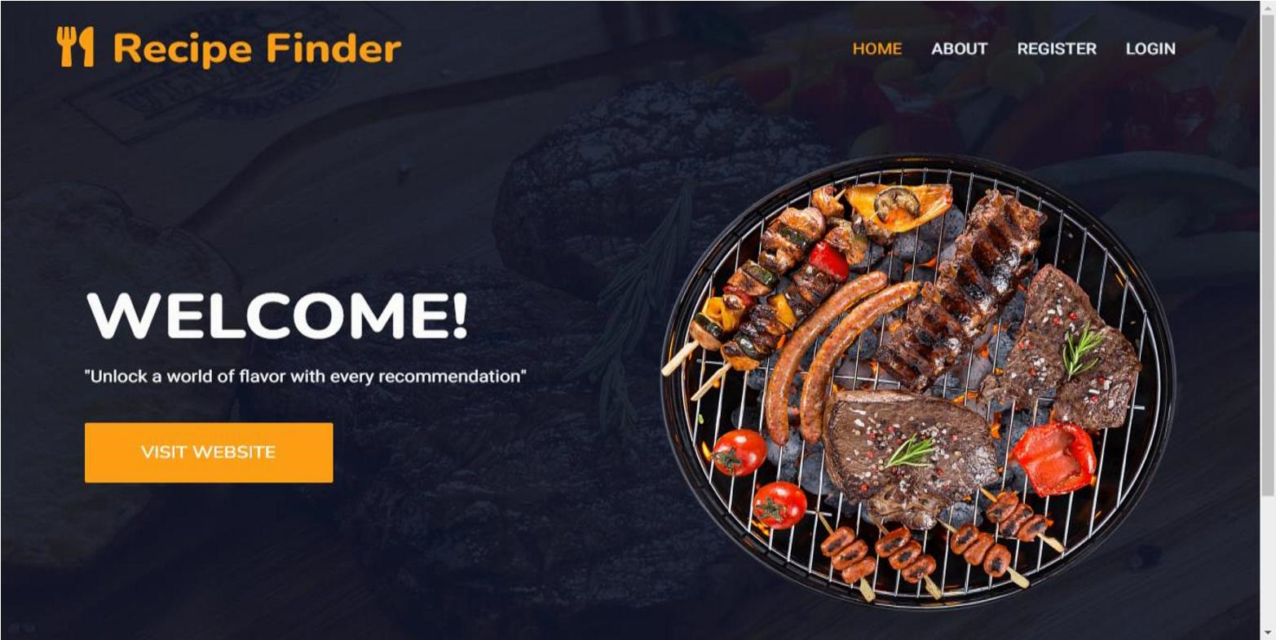

**About Page:**

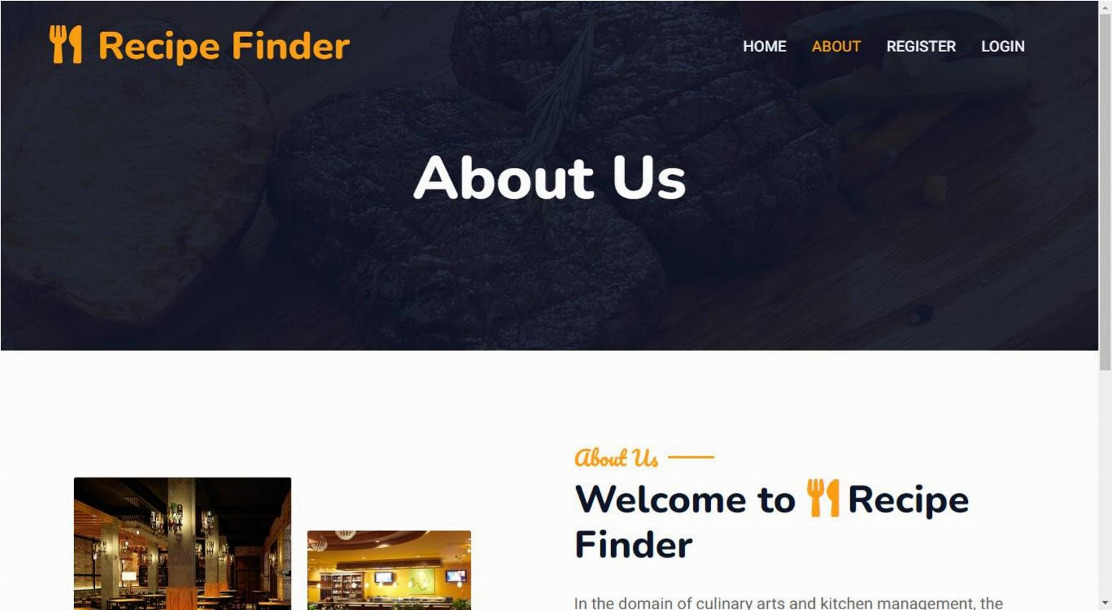

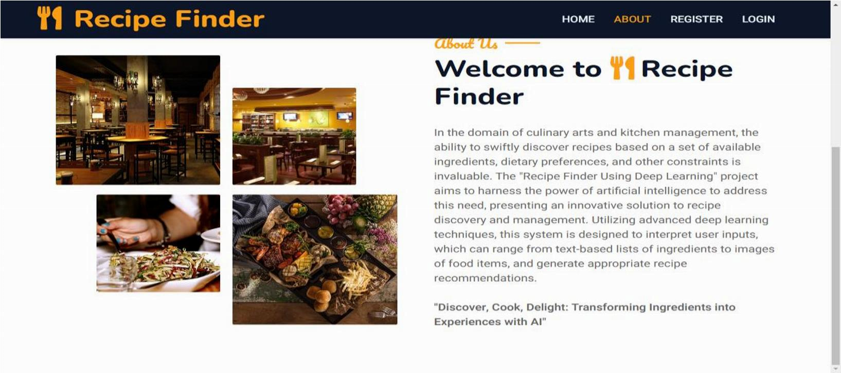

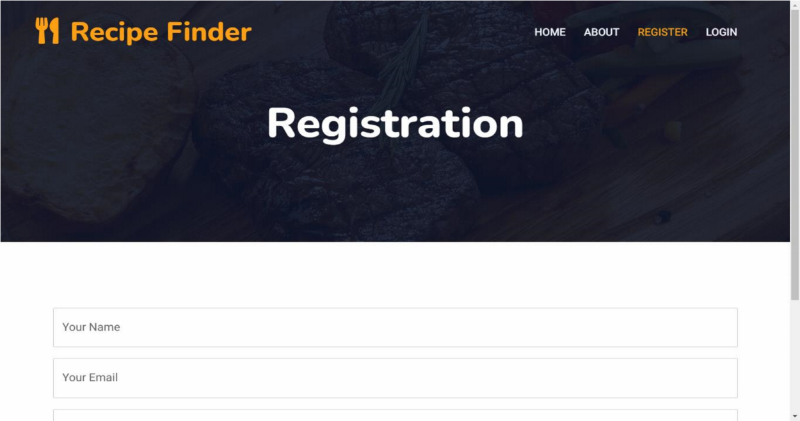**Registrations Page:**

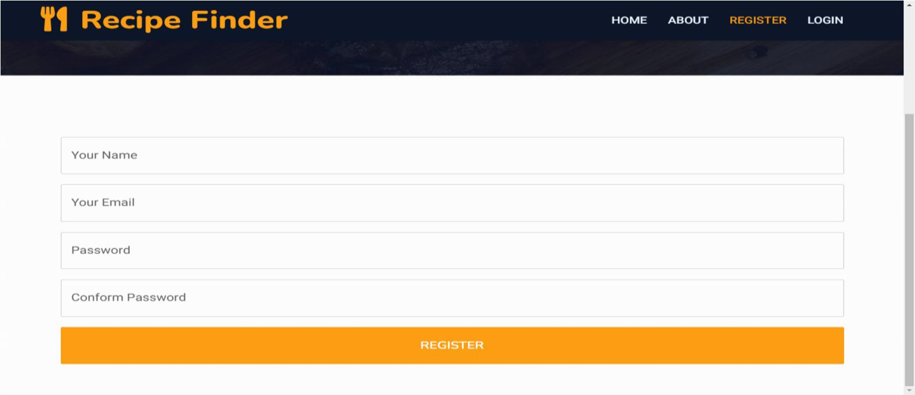

**Login page**

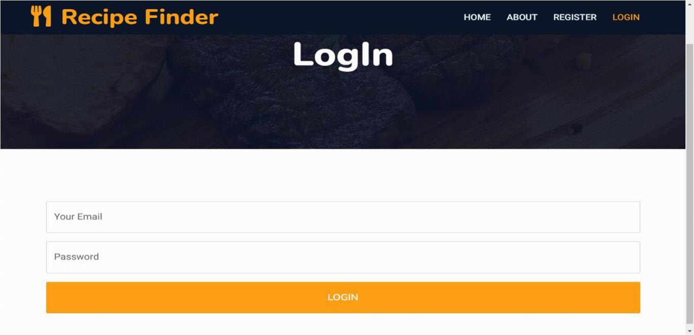

**User Home Page:**

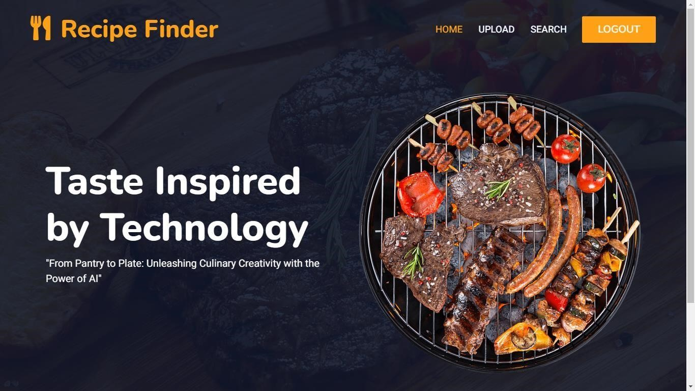

**Upload Image and Result Pages:**

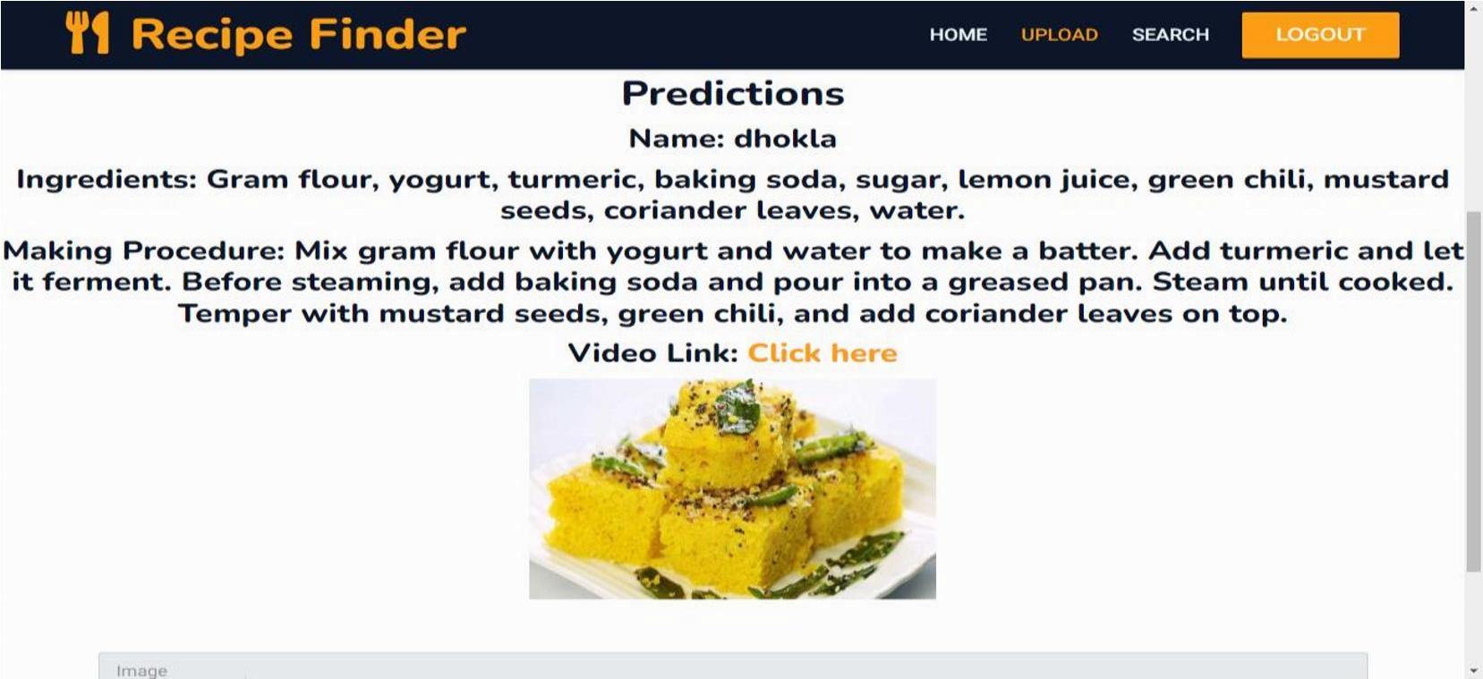

**Text Upload Page:**

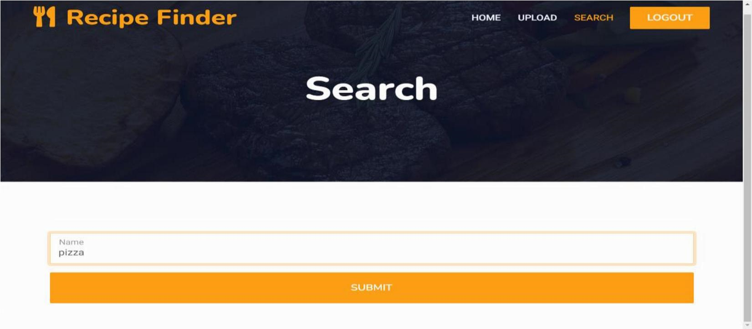

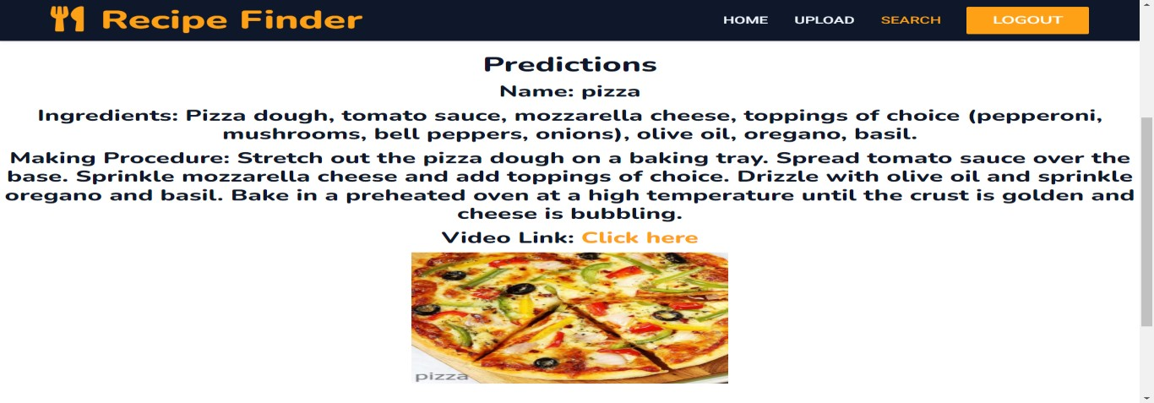

**Admin Home Page:**

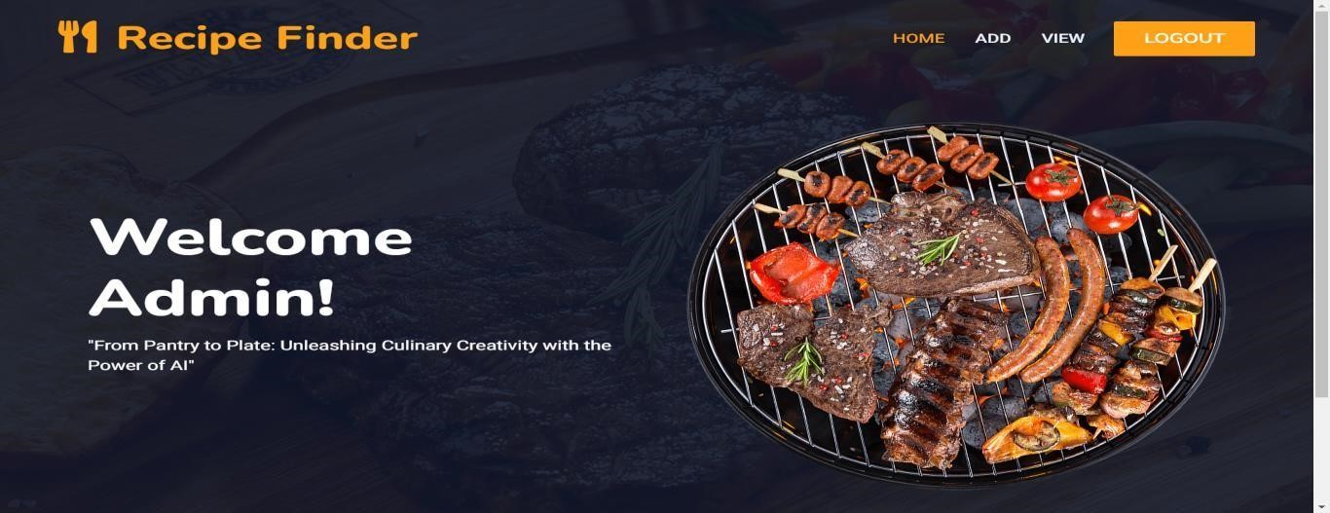

**Add Recipe Page:**

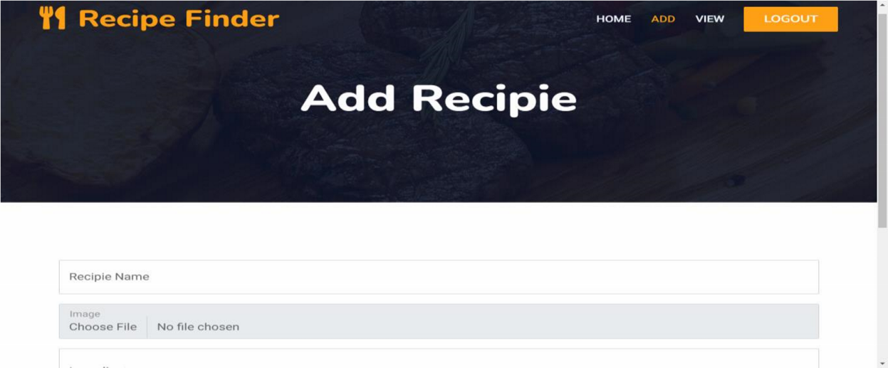

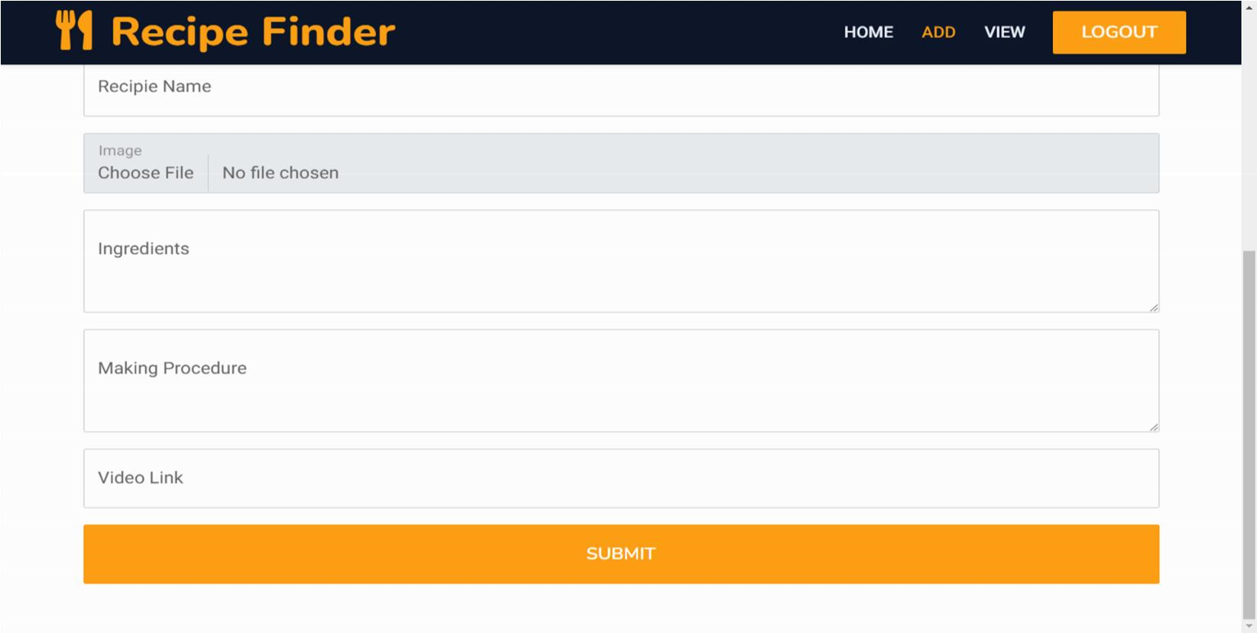

**Recipe View Page:**

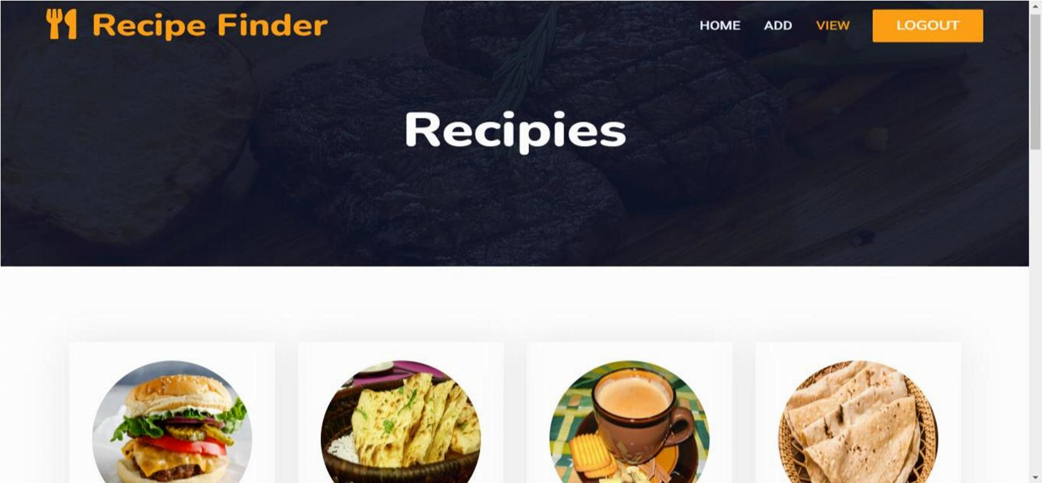

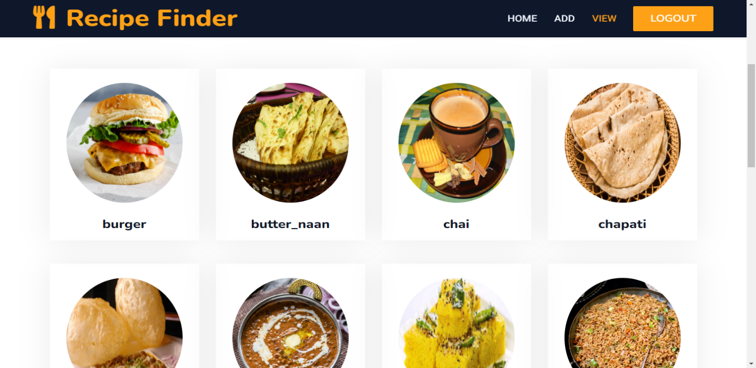

**Recipe Modification Page:**

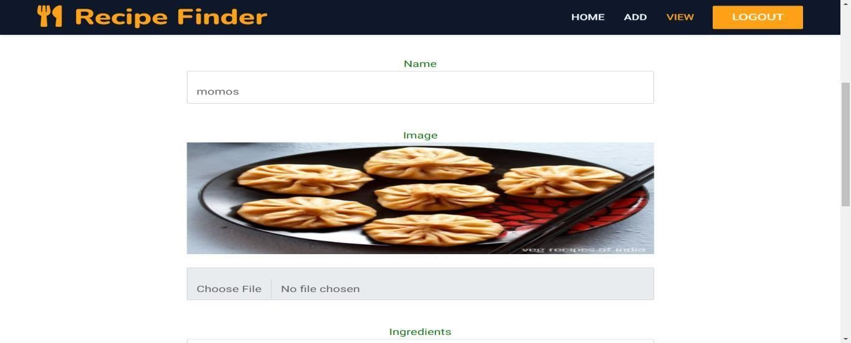

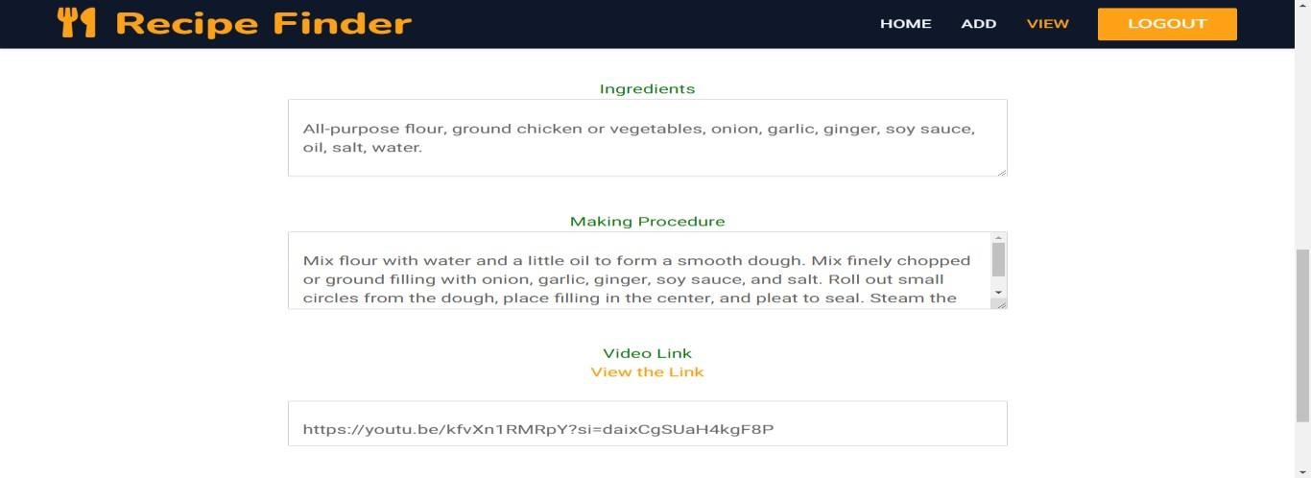

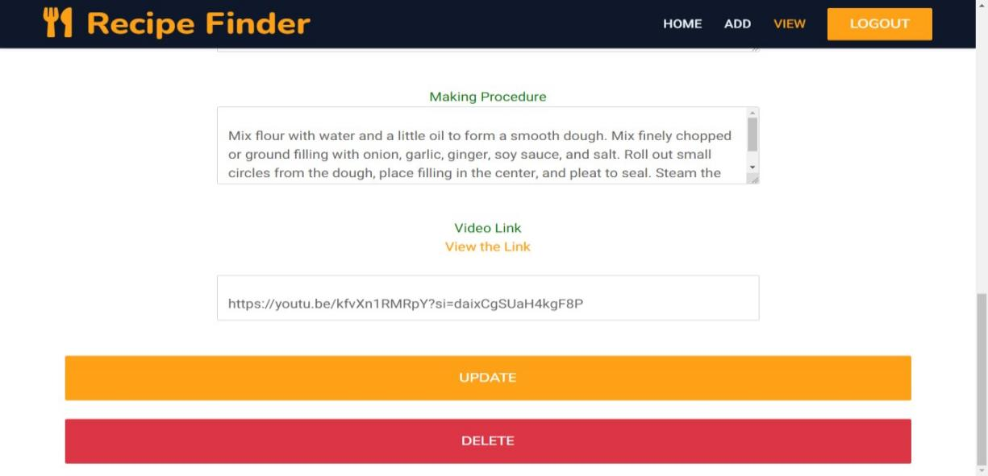

**9. CONCLUSION**

**Conclusion:**

In conclusion, the Recipe Recognition System represents a significant advancement in the field of culinary exploration and meal planning. By integrating Convolutional Neural Networks (CNNs) with traditional Recognition methodologies, the system offers a comprehensive and personalized approach to recipe discovery.

The proposed system addresses the limitations of existing methods by leveraging advanced technologies to capture the complex and nuanced characteristics of recipes. By considering visual elements such as presentation and aesthetic appeal, as well as textual attributes like ingredients and cooking techniques, the system offers a holistic understanding of recipe content, leading to more satisfying and enjoyable culinary experiences for users.

Moving forward, further research and development efforts will focus on refining the Recognition algorithms, enhancing user interaction interfaces, and continuously evaluating the system's performance to ensure its effectiveness and adaptability in meeting the evolving needs of users. Ultimately, the Recipe Recognition System aims to inspire culinary exploration, foster creativity in the kitchen, and enrich the overall cooking experience for users worldwide.

# 10. FURURE SCOPE

**Future Scope:**

In future enhancements, the Recipe Recognition System aims to advance its capabilities in several key areas. Firstly, by refining image recognition through improved CNN models, the system will be better equipped to identify intricate visual patterns within recipe images. Moreover, the integration of multi-modal fusion techniques will allow for a more comprehensive analysis by combining information from both image and text modalities, enhancing Recognition accuracy.

# 

# 11. REFERENCES

**Reference:**

[1] Seda Kul & Ahmet Sayar , “A Smart Recipe Recognition System Based on Image Processing and Deep Learning”, Kocaeli University, Baki Komsuoğlu bulvarı No:515, Umuttepe, 41001, Kocaeli, Turkey, 2021

[2] M. Gim, D. Park, M. Spranger, K. Maruyama and J. Kang, "RecipeBowl: A Cooking Recommender for Ingredients and Recipes Using Set Transformer," in IEEE Access, vol. 9, pp. 143623-143633, 2021,

[3] Devis Bianchini, Valeria De Antonellis, Nicola De Franceschi, Michele Melchiori, “PREFer: A prescription-based food recommender system” University of Brescia, Department of Information Engineering, via Branze 38, 25123 Brescia, Italy, 2017.

[4] W. Min, S. Jiang and R. Jain, "Food Recognition: Framework, Existing Solutions, and Challenges," in IEEE Transactions on Multimedia, vol. 22, no. 10, pp. 2659-2671, Oct. 2020.

[5]Mayumi Ueda, Mari Takahata, and Shinsuke Nakajima, “User’s Food Preference Extraction for Personalized Cooking Recipe Recognition” Kyoto University Yoshida Nihonmatsu-cho, Sakyo-ku, Kyoto, Kyoto 606–8501, Japan, 2018.